Appendix 1 Characteristics of Respondents

Characteristics | Total (n) | Percentage (%)
Gender
● Man | 187 | 52,0%
● Woman | 173 | 48,0%
Age
● 18<=X<=24 year | 73 | 20,3%
● 25<=X<=31 year | 110 | 30,6%
● 32<=X<=38 year | 93 | 25,8%
● 39<=X<=47 year | 61 | 16,9%
● 48<=X<=54 year | 15 | 4,2%
● >= 55 year | 8 | 2,2%
Education
● Senior High School | 28 | 7,8%
● Diploma | 31 | 8,6%
● Bachelor degree (S1) | 227 | 63,1%
● Master degree (S2) | 67 | 18,6%
● Doktor (S3) | 7 | 1,9%
Location
● Sumatera | 55 | 15,3%
● Jawa | 263 | 73,1%
● Kalimantan | 14 | 3,9%
● Sulawesi | 9 | 2,5%
● Bali/NTB/NTT | 12 | 3,3%
● Maluku/Papua | 7 | 1,9%

Appendix 2 Missing value and imputation

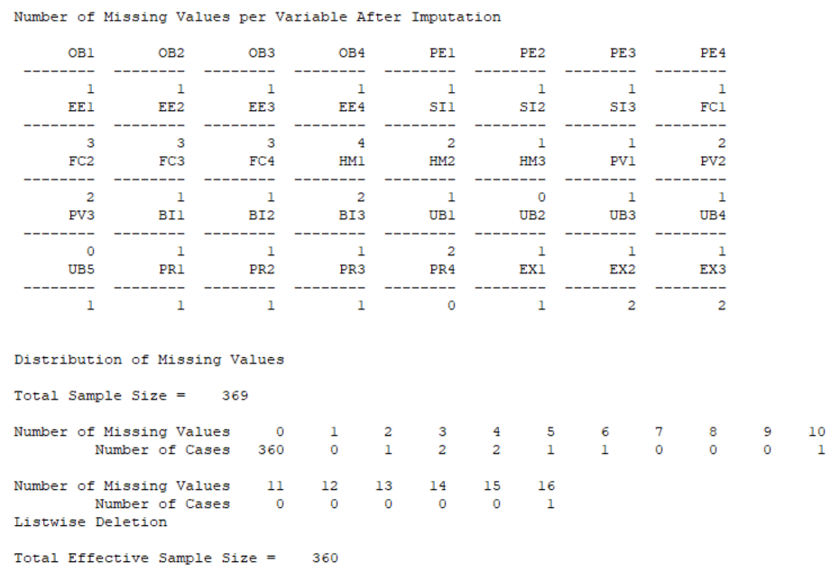

Appendix 3 Basic model t_{value}

First Model

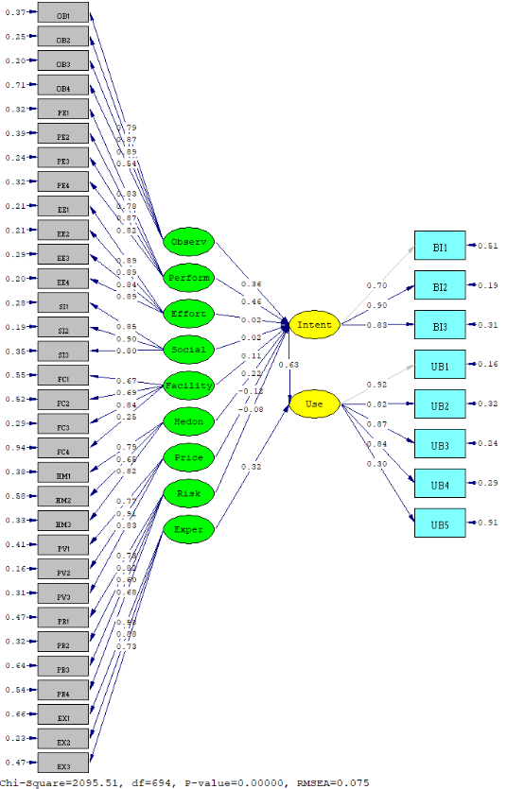

Appendix 4 Output lisrel from respesification model

DATE: 11/ 7/2019
TIME: 1:42

L I S R E L 8.80

BY

Karl G. J”reskog & Dag S”rbom

This program is published exclusively by
Scientific Software International, Inc.
7383 N. Lincoln Avenue, Suite 100
Lincolnwood, IL 60712, U.S.A.
Phone: (800)247-6113, (847)675-0720, Fax: (847)675-2140
Copyright by Scientific Software International, Inc., 1981-2006
Use of this program is subject to the terms specified in the
Universal Copyright Convention.
Website: www.ssicentral.com

The following lines were read from file D:\Lisrel Olah\Survey\hasil$$$.SPL:

Raw Data from file hasil.psf
!Asymptotic Covariance Matrix from File hasil.acm
Latent Variables: Observ Perform Effort Social Facility Hedon Price Risk Intent Exper Use

Relationships
OB1-OB4 = Observ
PE1-PE4 = Perform
EE1-EE4 = Effort
SI1-SI3 = Social
FC1-FC3 = Facility
HM1-HM3 = Hedon
PV1-PV3= Price
PR1 PR2 PR3 PR4 = Risk

BI1-BI3 = Intent
UB1-UB4 = Use
EX1-EX3 = Exper

!Effort = Observ
!Perform = Observ

Intent = Observ Perform Effort Social Facility Hedon Price Risk
Use= Intent Exper

Let error covariance between UB2 and UB1 Free
Let error covariance between UB4 and UB3 Free
!Let error covariance between OB3 and OB1 Free
Let error covariance between OB3 and OB2 Free

Let error covariance between PE2 and PE1 Free
Let error covariance between PE3 and PE2 Free
Let error covariance between PE4 and PE1 Free
Let error covariance between PE4 and PE2 Free

Let error covariance between EE2 and EE1 Free
Let error covariance between EE4 and EE2 Free
Let error covariance between EE4 and EE3 Free

Let error covariance between FC2 and FC1 Free
Let error covariance between FC3 and FC1 Free

Let error covariance between HM2 and HM1 Free

Let error covariance between PV2 and PV1 Free

!Let error covariance between OB4 and OB3 Free
!Let error covariance between EE3 and EE2 Free

!PSFFile from File olahsurevy.psf

Path Diagram
End of Problem

Sample Size = 360

Covariance Matrix

BI1 BI2 BI3 UB1 UB2 UB3
-------- -------- -------- -------- -------- --------
BI1 1.08
BI2 0.68 1.05
BI3 0.60 0.73 0.86
UB1 0.61 0.86 0.71 1.24
UB2 0.52 0.70 0.57 0.90 1.04
UB3 0.59 0.88 0.66 1.03 0.83 1.39
UB4 0.50 0.76 0.58 0.90 0.71 0.97
OB1 0.59 0.78 0.60 0.82 0.60 0.82
OB2 0.52 0.73 0.56 0.72 0.60 0.78
OB3 0.52 0.75 0.56 0.77 0.66 0.93
OB4 0.56 0.48 0.33 0.45 0.46 0.58
PE1 0.47 0.61 0.50 0.67 0.56 0.68
PE2 0.54 0.62 0.51 0.63 0.53 0.63
PE3 0.53 0.67 0.52 0.68 0.55 0.74
PE4 0.45 0.66 0.49 0.68 0.53 0.79
EE1 0.29 0.46 0.42 0.47 0.42 0.58
EE2 0.38 0.50 0.46 0.54 0.46 0.60
EE3 0.37 0.49 0.50 0.60 0.50 0.59
EE4 0.42 0.54 0.52 0.60 0.52 0.66
SI1 0.31 0.30 0.32 0.25 0.14 0.22
SI2 0.33 0.24 0.25 0.19 0.13 0.14
SI3 0.33 0.19 0.22 0.15 0.15 0.14
FC1 0.34 0.33 0.35 0.35 0.27 0.30
FC2 0.26 0.27 0.30 0.30 0.26 0.29
FC3 0.45 0.53 0.46 0.52 0.43 0.50
HM1 0.42 0.41 0.42 0.52 0.39 0.46
HM2 0.48 0.33 0.36 0.39 0.31 0.34
HM3 0.45 0.47 0.47 0.58 0.44 0.49
PV1 0.38 0.36 0.36 0.44 0.38 0.35
PV2 0.43 0.56 0.43 0.57 0.44 0.53
PV3 0.43 0.56 0.44 0.57 0.46 0.54
PR1 0.09 0.13 0.06 0.13 0.13 0.22
PR2 -0.03 0.02 -0.03 0.03 0.03 0.14
PR3 0.10 0.12 0.06 0.13 0.10 0.23
PR4 0.13 0.14 0.03 0.05 0.11 0.20
EX1 0.36 0.49 0.52 0.54 0.51 0.65
EX2 0.66 0.89 0.72 0.93 0.77 0.92
EX3 0.58 0.60 0.57 0.60 0.57 0.65

Covariance Matrix

UB4 OB1 OB2 OB3 OB4 PE1
-------- -------- -------- -------- -------- --------
UB4 1.12
OB1 0.72 1.28
OB2 0.66 0.79 1.01
OB3 0.68 0.80 0.84 1.10
OB4 0.44 0.64 0.48 0.65 1.41
PE1 0.56 0.57 0.55 0.56 0.43 0.82
PE2 0.48 0.53 0.49 0.52 0.49 0.61
PE3 0.58 0.61 0.53 0.63 0.46 0.60
PE4 0.56 0.62 0.65 0.77 0.43 0.52
EE1 0.52 0.44 0.48 0.52 0.22 0.35
EE2 0.52 0.46 0.54 0.56 0.27 0.42
EE3 0.54 0.52 0.50 0.50 0.23 0.39
EE4 0.56 0.53 0.51 0.56 0.29 0.42
SI1 0.19 0.15 0.27 0.23 -0.09 0.28
SI2 0.15 0.07 0.19 0.15 -0.03 0.24
SI3 0.14 0.09 0.12 0.09 0.16 0.23
FC1 0.33 0.30 0.25 0.27 0.32 0.26
FC2 0.22 0.25 0.23 0.26 0.26 0.22
FC3 0.40 0.42 0.43 0.42 0.39 0.45
HM1 0.47 0.44 0.40 0.37 0.32 0.39
HM2 0.37 0.36 0.25 0.29 0.48 0.30
HM3 0.48 0.43 0.44 0.44 0.32 0.40
PV1 0.35 0.41 0.37 0.43 0.36 0.34
PV2 0.52 0.68 0.55 0.60 0.48 0.48
PV3 0.53 0.58 0.52 0.59 0.47 0.50
PR1 0.08 0.06 0.10 0.22 0.18 0.17
PR2 0.04 0.04 0.10 0.14 0.09 0.10
PR3 0.11 0.10 0.22 0.29 0.12 0.17
PR4 0.12 0.17 0.20 0.26 0.24 0.12
EX1 0.54 0.45 0.45 0.51 0.33 0.41
EX2 0.87 0.76 0.74 0.75 0.45 0.63
EX3 0.50 0.50 0.51 0.53 0.26 0.47

Covariance Matrix

PE2 PE3 PE4 EE1 EE2 EE3
-------- -------- -------- -------- -------- --------
PE2 0.90
PE3 0.63 0.84
PE4 0.48 0.60 0.81
EE1 0.31 0.39 0.46 0.92
EE2 0.35 0.41 0.51 0.76 0.89
EE3 0.37 0.40 0.40 0.69 0.67 0.97
EE4 0.46 0.50 0.46 0.74 0.72 0.77
SI1 0.24 0.18 0.31 0.07 0.20 0.14
SI2 0.17 0.19 0.23 0.02 0.10 0.06
SI3 0.19 0.14 0.16 -0.04 0.04 0.00
FC1 0.31 0.28 0.21 0.17 0.22 0.21
FC2 0.29 0.20 0.19 0.19 0.23 0.20
FC3 0.50 0.47 0.37 0.25 0.30 0.34
HM1 0.40 0.30 0.29 0.27 0.36 0.39
HM2 0.39 0.29 0.18 0.15 0.22 0.23
HM3 0.45 0.39 0.34 0.26 0.35 0.39
PV1 0.36 0.38 0.30 0.22 0.29 0.32
PV2 0.46 0.54 0.44 0.30 0.34 0.36
PV3 0.47 0.52 0.47 0.33 0.39 0.36
PR1 0.21 0.22 0.20 0.08 0.13 0.06
PR2 0.07 0.07 0.11 0.07 0.11 0.04
PR3 0.15 0.14 0.23 0.17 0.22 0.19
PR4 0.08 0.12 0.22 0.13 0.21 0.12
EX1 0.37 0.37 0.41 0.41 0.47 0.49
EX2 0.61 0.67 0.64 0.52 0.55 0.62
EX3 0.44 0.48 0.49 0.40 0.42 0.46

Covariance Matrix

EE4 SI1 SI2 SI3 FC1 FC2
-------- -------- -------- -------- -------- --------
EE4 0.98
SI1 0.06 2.04
SI2 0.00 1.50 1.88
SI3 -0.03 1.23 1.26 1.61
FC1 0.24 0.10 0.12 0.20 0.76
FC2 0.21 0.09 0.11 0.15 0.38 0.56
FC3 0.35 0.15 0.17 0.13 0.40 0.38
HM1 0.41 0.33 0.23 0.31 0.26 0.22
HM2 0.31 0.05 0.16 0.20 0.29 0.17
HM3 0.38 0.31 0.26 0.21 0.30 0.19
PV1 0.32 0.22 0.12 0.14 0.28 0.18
PV2 0.37 0.10 0.09 0.08 0.34 0.19
PV3 0.36 0.20 0.16 0.10 0.34 0.18
PR1 0.10 0.14 0.18 0.15 0.01 0.05
PR2 0.06 0.17 0.12 0.10 -0.03 0.02
PR3 0.14 0.36 0.32 0.28 0.09 0.08
PR4 0.13 0.21 0.12 0.09 0.01 0.02
EX1 0.48 0.35 0.30 0.32 0.22 0.19
EX2 0.67 0.38 0.30 0.24 0.41 0.29
EX3 0.50 0.41 0.39 0.37 0.34 0.27

Covariance Matrix

FC3 HM1 HM2 HM3 PV1 PV2
-------- -------- -------- -------- -------- --------
FC3 0.77
HM1 0.29 0.75
HM2 0.28 0.45 0.85
HM3 0.32 0.47 0.42 0.76
PV1 0.25 0.38 0.41 0.39 1.12
PV2 0.40 0.35 0.37 0.47 0.82 1.14
PV3 0.36 0.35 0.34 0.44 0.68 0.82
PR1 0.11 0.03 0.10 0.09 0.20 0.21
PR2 0.05 0.02 0.02 0.01 0.06 0.07
PR3 0.09 0.06 0.02 0.10 0.24 0.16
PR4 0.01 0.03 0.05 0.03 0.14 0.12
EX1 0.30 0.40 0.26 0.42 0.25 0.35
EX2 0.55 0.47 0.31 0.52 0.38 0.54
EX3 0.38 0.40 0.32 0.39 0.35 0.39

Covariance Matrix

PV3 PR1 PR2 PR3 PR4 EX1
-------- -------- -------- -------- -------- --------
PV3 1.04
PR1 0.20 1.46
PR2 0.09 0.87 1.41
PR3 0.24 0.62 0.73 1.52
PR4 0.12 0.81 0.91 0.65 1.84
EX1 0.39 0.12 0.07 0.25 0.16 1.35
EX2 0.54 0.06 -0.02 0.17 0.11 0.67
EX3 0.39 0.05 -0.06 0.21 0.14 0.56

Covariance Matrix

EX2 EX3
-------- --------
EX2 1.40
EX3 0.83 1.16

Number of Iterations = 22

LISREL Estimates (Maximum Likelihood)

Measurement Equations

BI1 = 0.72*Intent, Errorvar.= 0.56 , Rý = 0.48
(0.044)
12.62

BI2 = 0.92*Intent, Errorvar.= 0.19 , Rý = 0.82
(0.058) (0.021)
16.04 9.25

BI3 = 0.77*Intent, Errorvar.= 0.27 , Rý = 0.69
(0.052) (0.023)
14.81 11.51

UB1 = 1.01*Use, Errorvar.= 0.22 , Rý = 0.82
(0.026)
8.33

UB2 = 0.82*Use, Errorvar.= 0.37 , Rý = 0.64
(0.035) (0.034)
23.41 11.02

UB3 = 1.02*Use, Errorvar.= 0.35 , Rý = 0.75
(0.043) (0.035)
23.51 10.02

UB4 = 0.88*Use, Errorvar.= 0.34 , Rý = 0.69
(0.041) (0.032)
21.54 10.75

OB1 = 0.90*Observ, Errorvar.= 0.47 , Rý = 0.63
(0.051) (0.041)
17.75 11.47

OB2 = 0.84*Observ, Errorvar.= 0.31 , Rý = 0.70
(0.045) (0.031)
18.85 9.94

OB3 = 0.91*Observ, Errorvar.= 0.27 , Rý = 0.76
(0.045) (0.030)
20.17 8.95

OB4 = 0.64*Observ, Errorvar.= 1.00 , Rý = 0.29
(0.060) (0.077)
10.65 12.97

PE1 = 0.75*Perform, Errorvar.= 0.26 , Rý = 0.68
(0.040) (0.025)
18.51 10.22

PE2 = 0.72*Perform, Errorvar.= 0.38 , Rý = 0.58
(0.045) (0.036)
16.05 10.71

PE3 = 0.78*Perform, Errorvar.= 0.23 , Rý = 0.73
(0.040) (0.021)
19.81 10.85

PE4 = 0.78*Perform, Errorvar.= 0.20 , Rý = 0.75
(0.039) (0.022)
20.13 9.13

EE1 = 0.79*Effort, Errorvar.= 0.29 , Rý = 0.68
(0.043) (0.031)
18.23 9.45

EE2 = 0.79*Effort, Errorvar.= 0.28 , Rý = 0.69
(0.044) (0.033)
18.07 8.39

EE3 = 0.86*Effort, Errorvar.= 0.23 , Rý = 0.77
(0.045) (0.036)
19.29 6.33

EE4 = 0.94*Effort, Errorvar.= 0.095 , Rý = 0.90
(0.043) (0.034)
22.08 2.77

SI1 = 1.22*Social, Errorvar.= 0.56 , Rý = 0.72
(0.064) (0.065)
19.13 8.73

SI2 = 1.23*Social, Errorvar.= 0.37 , Rý = 0.80
(0.060) (0.057)
20.67 6.48

SI3 = 1.02*Social, Errorvar.= 0.57 , Rý = 0.65
(0.058) (0.055)
17.67 10.32

FC1 = 0.60*Facility, Errorvar.= 0.41 , Rý = 0.47
(0.057) (0.058)
10.54 7.06

FC2 = 0.46*Facility, Errorvar.= 0.36 , Rý = 0.37
(0.040) (0.031)
11.36 11.41

FC3 = 0.83*Facility, Errorvar.= 0.075 , Rý = 0.90
(0.048) (0.055)
17.52 1.36

HM1 = 0.65*Hedon, Errorvar.= 0.32 , Rý = 0.57
(0.042) (0.032)
15.63 9.91

HM2 = 0.56*Hedon, Errorvar.= 0.54 , Rý = 0.37
(0.048) (0.046)
11.56 11.72

HM3 = 0.72*Hedon, Errorvar.= 0.23 , Rý = 0.69
(0.041) (0.030)
17.76 7.69

PV1 = 0.75*Price, Errorvar.= 0.56 , Rý = 0.50
(0.053) (0.053)
14.05 10.55

PV2 = 0.93*Price, Errorvar.= 0.28 , Rý = 0.76
(0.048) (0.041)
19.19 6.76

PV3 = 0.89*Price, Errorvar.= 0.26 , Rý = 0.75
(0.046) (0.037)
19.18 6.93

PR1 = 0.88*Risk, Errorvar.= 0.69 , Rý = 0.53
(0.061) (0.069)
14.47 9.92

PR2 = 0.98*Risk, Errorvar.= 0.45 , Rý = 0.68
(0.058) (0.064)
16.91 7.08

PR3 = 0.74*Risk, Errorvar.= 0.98 , Rý = 0.36
(0.065) (0.083)
11.36 11.78

PR4 = 0.92*Risk, Errorvar.= 0.99 , Rý = 0.46
(0.069) (0.092)
13.29 10.83

EX1 = 0.67*Exper, Errorvar.= 0.90 , Rý = 0.34
(0.059) (0.071)
11.49 12.61

EX2 = 1.04*Exper, Errorvar.= 0.31 , Rý = 0.78
(0.052) (0.043)
20.11 7.19

EX3 = 0.78*Exper, Errorvar.= 0.55 , Rý = 0.52
(0.051) (0.047)
15.28 11.65

Error Covariance for UB2 and UB1 = 0.075
(0.023)
3.24

Error Covariance for UB4 and UB3 = 0.071
(0.025)
2.80

Error Covariance for OB3 and OB2 = 0.070
(0.024)
2.88

Error Covariance for PE2 and PE1 = 0.072
(0.022)
3.29

Error Covariance for PE3 and PE2 = 0.055
(0.021)
2.66

Error Covariance for PE4 and PE1 = -0.06
(0.017)
-3.68

Error Covariance for PE4 and PE2 = -0.08
(0.020)
-3.93

Error Covariance for EE2 and EE1 = 0.14
(0.027)
4.94

Error Covariance for EE4 and EE2 = -0.02
(0.017)
-1.23

Error Covariance for EE4 and EE3 = -0.05
(0.029)
-1.55

Error Covariance for FC2 and FC1 = 0.11
(0.032)
3.57

Error Covariance for FC3 and FC1 = -0.10
(0.042)
-2.33

Error Covariance for HM2 and HM1 = 0.085
(0.029)
2.95

Error Covariance for PV2 and PV1 = 0.12
(0.038)
3.25

Structural Equations

Intent = 0.48*Observ + 0.33*Perform + 0.021*Effort + 0.022*Social + 0.12*Facility + 0.25*Hedon - 0.15*Price - 0.079*Risk,
sk, (0.12) (0.12) (0.044) (0.036) (0.043) (0.064) (0.056) (0.032)
3.96 2.82 0.49 0.62 2.78 3.86 -2.64 -2.48 Rý

Errorvar.= 0.083 , Rý = 0.92
(0.022)
3.70

Use = 0.66*Intent + 0.30*Exper, Errorvar.= 0.14 , Rý = 0.86
(0.084) (0.077) (0.023)
7.86 3.88 5.82

Reduced Form Equations

Intent = 0.48*Observ + 0.33*Perform + 0.021*Effort + 0.022*Social + 0.12*Facility + 0.25*Hedon - 0.15*Price - 0.079*Risk
sk + (0.12) (0.12) (0.044) (0.036) (0.043) (0.064) (0.056) (0.032)
3.96 2.82 0.49 0.62 2.78 3.86 -2.64 -2.48 +

+ 0.0*Exper, Errorvar.= 0.083, Rý = 0.92

Use = 0.32*Observ + 0.22*Perform + 0.014*Effort + 0.015*Social + 0.080*Facility + 0.16*Hedon - 0.098*Price - 0.053*Risk
Risk (0.088) (0.078) (0.029) (0.024) (0.030) (0.046) (0.039) (0.022)
3.64 2.75 0.48 0.62 2.67 3.60 -2.52 -2.40 +

+ 0.30*Exper, Errorvar.= 0.17, Rý = 0.83
(0.077)
3.88

Correlation Matrix of Independent Variables

Observ Perform Effort Social Facility Hedon
-------- -------- -------- -------- -------- --------
Observ 1.00
Perform 0.90 1.00
(0.02)
46.93
Effort 0.65 0.64 1.00
(0.04) (0.04)
17.49 17.71
Social 0.14 0.25 0.04 1.00
(0.06) (0.06) (0.06)
2.34 4.46 0.70
Facility 0.57 0.65 0.44 0.16 1.00
(0.05) (0.04) (0.05) (0.06)
12.34 15.25 9.17 2.88
Hedon 0.67 0.67 0.60 0.31 0.57 1.00
(0.04) (0.04) (0.04) (0.06) (0.05)
16.41 16.99 13.97 5.45 11.60
Price 0.73 0.68 0.45 0.12 0.52 0.67
(0.03) (0.04) (0.05) (0.06) (0.05) (0.04)
21.38 19.35 9.44 2.07 10.78 15.98
Risk 0.19 0.21 0.12 0.16 0.07 0.07
(0.06) (0.06) (0.06) (0.06) (0.06) (0.06)
3.13 3.55 2.07 2.62 1.18 1.04
Exper 0.81 0.81 0.70 0.29 0.61 0.72
(0.03) (0.03) (0.04) (0.06) (0.05) (0.04)
28.19 29.39 19.79 5.05 13.42 18.55

Correlation Matrix of Independent Variables

Price Risk Exper
-------- -------- --------
Price 1.00
Risk 0.17 1.00
(0.06)
2.77
Exper 0.56 0.08 1.00
(0.05) (0.06)
12.30 1.22

Covariance Matrix of Latent Variables

Intent Use Observ Perform Effort Social
-------- -------- -------- -------- -------- --------
Intent 1.00
Use 0.92 1.00
Observ 0.90 0.84 1.00
Perform 0.90 0.84 0.90 1.00
Effort 0.67 0.65 0.65 0.64 1.00
Social 0.24 0.24 0.14 0.25 0.04 1.00
Facility 0.68 0.63 0.57 0.65 0.44 0.16
Hedon 0.77 0.73 0.67 0.67 0.60 0.31
Price 0.65 0.60 0.73 0.68 0.45 0.12
Risk 0.09 0.08 0.19 0.21 0.12 0.16
Exper 0.84 0.86 0.81 0.81 0.70 0.29

Covariance Matrix of Latent Variables

Facility Hedon Price Risk Exper
-------- -------- -------- -------- --------
Facility 1.00
Hedon 0.57 1.00
Price 0.52 0.67 1.00
Risk 0.07 0.07 0.17 1.00
Exper 0.61 0.72 0.56 0.08 1.00

Goodness of Fit Statistics

Degrees of Freedom = 605
Minimum Fit Function Chi-Square = 1575.21 (P = 0.0)
Normal Theory Weighted Least Squares Chi-Square = 1672.26 (P = 0.0)
Estimated Non-centrality Parameter (NCP) = 1067.26
90 Percent Confidence Interval for NCP = (949.28 ; 1192.86)

Minimum Fit Function Value = 4.39
Population Discrepancy Function Value (F0) = 2.97
90 Percent Confidence Interval for F0 = (2.64 ; 3.32)
Root Mean Square Error of Approximation (RMSEA) = 0.070
90 Percent Confidence Interval for RMSEA = (0.066 ; 0.074)
P-Value for Test of Close Fit (RMSEA < 0.05) = 0.00

Expected Cross-Validation Index (ECVI) = 5.42
90 Percent Confidence Interval for ECVI = (5.09 ; 5.77)
ECVI for Saturated Model = 4.13
ECVI for Independence Model = 117.04

Chi-Square for Independence Model with 703 Degrees of Freedom = 41942.89
Independence AIC = 42018.89
Model AIC = 1944.26
Saturated AIC = 1482.00
Independence CAIC = 42204.56
Model CAIC = 2608.77
Saturated CAIC = 5102.60

Normed Fit Index (NFI) = 0.96
Non-Normed Fit Index (NNFI) = 0.97
Parsimony Normed Fit Index (PNFI) = 0.83
Comparative Fit Index (CFI) = 0.98
Incremental Fit Index (IFI) = 0.98
Relative Fit Index (RFI) = 0.96

Critical N (CN) = 158.00

Root Mean Square Residual (RMR) = 0.056
Standardized RMR = 0.049
Goodness of Fit Index (GFI) = 0.80
Adjusted Goodness of Fit Index (AGFI) = 0.76
Parsimony Goodness of Fit Index (PGFI) = 0.66

The Modification Indices Suggest to Add the
Path to from Decrease in Chi-Square New Estimate
BI1 Use 14.9 -0.58
OB1 Perform 10.3 -0.53
OB4 Effort 7.9 -0.22
OB4 Exper 8.5 -0.35
PE2 Facility 11.0 0.16
PE2 Hedon 17.6 0.25
PE4 Observ 29.5 0.74
PE4 Facility 29.4 -0.25
PE4 Hedon 13.3 -0.21
PE4 Price 8.9 -0.16
EE1 Hedon 25.0 -0.20
EE2 Observ 13.9 0.16
EE2 Perform 18.6 0.17
EE2 Social 8.4 0.08
EE2 Hedon 12.7 0.14
EE2 Price 9.2 0.10
FC1 Perform 15.0 -0.43
FC1 Hedon 9.7 0.25
FC1 Price 8.9 0.19
FC3 Perform 9.5 0.45
FC3 Hedon 12.4 -0.37
HM2 Exper 8.7 -0.23
PV1 Observ 9.8 -0.22
PV3 Perform 8.8 0.28
PR2 Observ 8.8 -0.15
PR2 Perform 9.5 -0.16
PR2 Exper 8.4 -0.15
PR3 Social 9.3 0.18
EX3 Social 9.8 0.15
Intent Exper 17.0 0.38
Use Observ 20.3 0.44
Use Perform 12.4 0.35
Use Social 14.5 -0.13

The Modification Indices Suggest to Add an Error Covariance
Between and Decrease in Chi-Square New Estimate
Use Intent 18.1 -0.08
UB3 BI3 10.8 -0.06
OB1 UB1 9.4 0.06
OB1 UB2 8.6 -0.07
OB3 UB3 38.7 0.11
OB4 BI1 21.0 0.19
OB4 BI3 8.2 -0.09
OB4 UB1 10.0 -0.09
OB4 OB3 10.9 0.10
PE3 OB2 17.5 -0.06
PE4 BI1 9.0 -0.06
PE4 BI3 8.0 -0.04
PE4 UB3 36.3 0.10
PE4 UB4 10.3 -0.05
PE4 OB3 55.2 0.11
EE1 BI1 8.1 -0.06
EE1 UB1 9.8 -0.04
EE2 PE4 11.5 0.04
EE3 UB1 8.4 0.04
EE3 PE4 8.7 -0.05
EE3 EE2 9.4 -0.08
EE4 PE3 11.8 0.05
SI1 OB4 16.0 -0.19
SI1 PE4 8.8 0.07
SI3 OB4 20.7 0.20
FC1 UB3 10.0 -0.07
FC1 UB4 8.5 0.06
FC2 PE3 11.3 -0.05
FC3 FC2 17.0 2.00
HM1 PE1 8.0 0.05
HM1 PE3 14.0 -0.06
HM1 SI2 11.9 -0.09
HM1 SI3 9.0 0.08
HM2 BI1 26.6 0.15
HM2 OB2 10.1 -0.07
HM2 OB4 42.1 0.26
HM2 PE4 13.4 -0.07
HM2 SI1 26.5 -0.18
PV1 BI2 10.9 -0.06
PV1 BI3 8.2 0.06
PV1 FC3 9.9 -0.07
PV2 OB1 17.3 0.10
PV2 PE3 8.0 0.04
PR1 OB2 8.0 -0.08
EX2 BI2 20.6 0.09
EX2 UB4 15.3 0.09
EX3 BI1 12.8 0.11
EX3 UB1 8.4 -0.06
EX3 UB4 10.1 -0.08

Time used: 0.719 Seconds

