Satisfaction of Domestic Leisure Travel based on Age Range – Case of Japan
Kenichi Shimamoto

ABSTRACT

Tourism has a large effect on lifestyle, society and the economy. With policy goals aiming to develop Japan into a tourism nation, it has become important for Japan to understand tourism trends and satisfaction. This paper focuses on tourists’ satisfaction based on age range for Japan domestic leisure travel with overnight stays by Japan residents. It examines the characteristics concerning the satisfaction of the travellers by each age range. The results find that the younger age ranges trend to be relatively ‘satisfied’ with their travels and the older age ranges were relatively dissatisfied, with the 50s and 60s age ranges showing a strong tendency of being ‘very dissatisfied’. The age range closest to the average was the 40s.

Keywords: Japan domestic leisure travel, age range, travel satisfaction
JEL Classifications: Z30, Z33

INTRODUCTION

The tourism market is listed as a focus market for development in Japan, according to the Tourism-based Country Promotion Basic Act (Japan Tourism Agency, 2017) which considers the wide impact the tourism market has on society and the economy on both the supply side and the demand side (Kawamura, 2008). Japan has been introducing policies to encourage inbound travel alongside reinforcement of domestic tourism by Japanese residents with the aim of becoming a tourism nation. This has stimulated the need for destination marketers to understand the satisfaction of tourists. The importance of tourist satisfaction on destination choice is reflected in the wide range of literature available. Tourist satisfaction has been studied to understand its influence over potential visitors and their decision to return (Baker and Crompton, 2000; Kozak and Rimmingto, 2000; Petrick, 2004; Huh et al., 2006; Chen and Tsai, 2007; Chi and Qu, 2008; Prayag and Ryan, 2012; Ramseook-Munhurrun, et al., 2015). It has also been studied to evaluate the performance of a destination (Korzay and Alvarez, 2005; Compo and Garau, 2008). In addition to these influences, tourist satisfaction affects the consumption of goods and services, making it key for destination marketing success (Kozak and Rimmington, 2000). The relationship between tourist satisfaction and positive word-of-mouth communication has been conducted (e.g. Ross, 1993; Pizam, 1994, Hallowell, 1996; Beeho and Prentice, 1997; Oppermann, 2000; Yoon and Uysal, 2005; Chi and Qu, 2008) alongside studies on dissatisfaction and negative word-of-mouth communication (Peter and Olson, 1987; Almanza et al., 1994; Pizam, 1994). Some literatures suggest that the impact negative situations have on the visitor’s overall satisfaction and decision to return are greater than positive situations (Chung and Hoffman, 1998; Petrick et al., 2006). In order to address or mitigate areas of dissatisfaction, information on satisfaction and dissatisfaction by the demographic of visitors will be critical.
In order to understand a market, research is often conducted by applying demographic variables to analyse each segment of the market. The benefits of using demographic variables are that the variables are easy to measure and can assist in analysing the relationship with human behaviours and preferences such as consumption (Kotler and Keller, 2010). Demographic characteristics have been examined in past studies on travel to understand motivation, preference and behaviour patterns such as lodging preference and travel related expenditure (e.g. Crask, 1981; Lieux et al., 1994; Heung et al., 2001; Johns and Gyimóthy, 2002; Oh et al., 2004; Jönsson and Devonish, 2008; Bernini and Cracolici, 2015). Demographic factors such as age, gender, marital status, occupation and monthly income are also examined in studies on tourist satisfaction (Rittichainuwat, et. al, 2002; Tsiotsou and Vasioti, 2006). This paper applies the demographic variable of age range to the analysis. In a majority of the studies listed above include age as a demographic factor. However, research on Japan domestic travel which examines age are limited. There is the study by Ito (2016) on the number tourists and share of tourists without overnight stays that observes age. GF (2011) study senior tourists and their frequency of travel and their partners by age and gender. The Development Bank of Japan and the Japan Economic Research Institute (2017) study the number of total business travellers, length of business travel days and the share of business travel for each age range. The results find that the 40 to 49 age range have the highest value for all three observations. JTB (2015) conduct a study on the motivation of domestic and international travel by age range, which find that the younger the age group, the higher the motivation for both domestic and international travel. Atami city (2018) examines the frequency of travel, travel goals, travel activity, travel partner, transportation, accommodation, length of travel days and travel expenditure based on age range. However, past studies have not studied the degree of travel satisfaction supported by each age range. It aims to fill gaps in past studies on travel by analysing the satisfaction of tourists based on age range concerning Japan domestic leisure travel. The examination of the characteristics and similarities concerning the degree of travel satisfaction by age range is to attempt to provide insight for marketers of the travel industry.
The next section will cover the methodology and data and the third section will provide the results and make observations of any characteristics. This is followed by the discussion and conclusion which will provide some policy implications and future research questions.

METHODS AND DATA

This paper examines the Japan domestic leisure travel market applying data from the Japan National Tourism Survey from 2012 to 2016 made available from the Japan Tourism Agency on the travellers’ satisfaction by age range for Japan domestic overnight travel. The Japan National Tourism Survey is a survey sent twice a year to a random sampling of 2.5million residents in Japan (from the Basic Residents Registry).There are nine age ranges covered by the data, which are 0 to 9 years of age (0-9); 10 to 19 years of age (10s); 20 to 29 years of age (20s); 30 to 39 years of age (30s); 40 to 49 years of age (40s); 50 to 59 years of age (50s); 60 to 69 years of age (60s); 70 to 79 years of age (70s); and over 80 years of age (80s+). Concerning the degree of tourist satisfactions, they are categorized into the following seven. The degree of satisfaction for travel with overnight stays are, very satisfied; satisfied; slightly satisfied; neutral; slightly dissatisfied; dissatisfied; and very dissatisfied.
The analysis is conducted as follows. First, we will obtain the share of each degree of satisfaction for all travellers.

$U_{Ai}^{o}=\frac{N_{Ai}^{o}}{N_{AI}^{o}}$ (1)

Here, N represents the number of tourists for each degree of satisfaction for domestic leisure travel in Japan. i is each degree of satisfaction. I is degree of overall satisfaction. A denotes all age ranges. o represents overnight travel.
Next, the share of degree of satisfaction by age range will be determined. Here, age range is depicted by a.

$U_{ai}^{o}=\frac{N_{ai}^{o}}{N_{aI}^{o}}$ (2)

By dividing (2) by (1), the size of the share of the degree of satisfaction by age range can be compared to the total tourists’ share for the same degree of satisfaction. Hence, (3) below represents, the relative size of the support (relative support) for each degree of satisfaction by age range. When (3) is less than 1, then the support is weaker than the average; when it is greater than 1, then the support is greater than the average; and when it is 1, then the support is equivalent to the average.

$P_{ai}^{o}=\frac{U_{ai}^{o}}{U_{Ai}^{o}}$ (3)

If the value introduced from equation (3) is calculated based on only one fiscal year, there is the risk that the one fiscal year is an anomaly and the value is unreliable. In order to address this possibility, this study adopts the mean for 2012 to 2016.

RESULTS
The results of the relative support for each degree of satisfaction by age range will be observed.

Figure 1: Relative Support by Age Range

VS: very satisfied, S: satisfied, SS: slightly satisfied, N: neutral, SDS: slightly dissatisfied, DS: dissatisfied, VDS: very dissatisfied

From Table 1, the following characteristics were identified.
- Concerning 0-9, the relative support is greater as the degree of satisfaction increases, with ‘very satisfied’ being very large. The results for ‘slightly satisfied’, ‘neutral’, ‘slightly dissatisfied’, ‘dissatisfied’, are lower than the average of all travellers, with some at a considerable level.
- The results of the 10s are considerable with the greatest result for ‘very satisfied’ of all the age ranges and a very small relative support of ‘very dissatisfied’. There was also a very large result for ‘neutral’
- The 20s were similar to the 0-9 and showed a greater relative support with a higher degree of satisfaction, especially ‘very satisfied’. The share for ‘neutral’ was small, ‘dissatisfied’ was considerably smaller and ‘very dissatisfied’ much smaller than the average.
- The 30s show a very large result concerning ‘very satisfied’ and very small relative support of ‘slightly dissatisfied’ and ‘dissatisfied’. However, the result for ‘very dissatisfied’ is greater than the average.
- The 40s which are in the middle of all the age ranges are near the average for most of the degrees of satisfaction, which suggests that the 40s are not much different from the overall average. However, ‘very dissatisfied’ is considerably low.
- Concerning the 50s, the higher the degree of satisfaction, the smaller the relative support, with the results for ‘very satisfied’, being very small. For all the degrees of dissatisfied, the relative support is higher than the average. Relative support for ‘very dissatisfied’ is considerably high and the greatest amongst all age ranges.
- The 60s are similar to the 50s. The higher the degree of satisfaction, the smaller the relative support, with the results for ‘very satisfied’ being considerably low. The results of all the degrees of dissatisfaction are higher than the average, especially ‘very dissatisfied’.
- The characteristics of the 70s is the small relative support for both extremes in satisfaction. This suggests a modest reaction of “very satisfied’ and ‘very dissatisfied’.
- 80s+ show a very high result concerning ‘dissatisfied’, although considerably low results for ‘slightly dissatisfied’ and ‘very dissatisfied’. There is also an indication of a very low result for ‘very satisfied’.

Figure 2: Relative Support for Each Degree of Satisfaction

VS: very satisfied, S: satisfied, SS: slightly satisfied, N: neutral, SDS: slightly dissatisfied, DS: dissatisfied, VDS: very dissatisfied

Next, based on Figure 2, we will examine the characteristics of the relative support for each degree of satisfaction.
- The results indicate that the lower age ranges tend to show a higher relative support for ‘very satisfied’. In contrast, the higher age ranges tend to show a very low relative support for ‘very satisfied’. The 0 to 30s age ranges show very high relative support of ‘very satisfied’, with the 10s showing considerably high results. On the other hand, the 60s and 70s show considerably low results.
- Characteristic of ‘satisfied’ is that the results are near the average with the lower age ranges showing slightly lower relative support and the higher age ranges indicating slightly higher relative support.
- Results for ‘slightly satisfied’ is similar to the results of ‘satisfied’ and there is little difference with the average with a slight tendency of lower than average for the lower age ranges and slightly higher for the higher age ranges.
- The relative support for ‘neutral’ grows from the 20s to the 60s. The results for 10s and 60s are very high and the 0-9 are considerably low.
- Concerning ‘slightly dissatisfied, the results for the lower age ranges are lower than the average and the higher age ranges are higher. However, 80s+ shows a considerably low result.
- The results show that ‘dissatisfied’ gain greater relative support as the age ranges get higher. The relative support from 0 to 20s are considerably low, but support from 80s+ is very high.
- Concerning ‘very dissatisfied’, the fluctuations amongst the age ranges are large. In particular, results for 50s is considerably high and the 60s is very high. On the other hand, 70s and 80s+ are considerably low.

Table 1: Standard Deviation Amongst Age Ranges
 | VS | S | SS | N | SDS | DS | VDS
Standard Deviation | 0.384 | 0.083 | 0.141 | 0.245 | 0.223 | 0.311 | 0.434
 | (2) | (7) | (6) | (4) | (5) | (3) | (1)
* Number in parentheses represent the rank order
VS: very satisfied, S: satisfied, SS: slightly satisfied, N: neutral, SDS: slightly dissatisfied, DS: dissatisfied, VDS: very dissatisfied

We will examine whether the relative support for each degree of satisfaction amongst the age ranges are similar or disperse, using the standard deviation. The objective for the analysis is to understand if there are any age ranges that need to be given special consideration or targeted separately. The results of Table 1 show that the value for ‘very dissatisfied’ is the largest at 0.434, which suggests the largest dispersity amongst the age ranges concerning their relative support. ‘Very satisfied’ is the second largest at the value of 0.384. ‘Dissatisfied’ is the third largest at the value of 0.311. The middle position is ‘neutral’ with 0.245 followed by ‘slightly dissatisfied’ with 0.223. ‘Slightly dissatisfied’ is the second smallest with the value of 0.141, and ‘satisfied’ is the smallest at the value of 0.083, suggesting that the difference in the relevant support from the age ranges is the smallest.
From the above results, ‘very dissatisfied’, ‘dissatisfied’ and ‘very satisfied’ are the three most disperse degrees of satisfaction, meaning that the differences amongst the age ranges are large. Therefore, we will focus on these three degrees of satisfaction to further understand the similarities or dissimilarities amongst the age ranges employing the hierarchical cluster analysis. This analysis is suitable for the limited number of age ranges available and that the number of groups do not need to be determined in advance. The similarities between the age ranges based on their relative support for each degree of satisfaction are calculated using the Wards linkage method which is often used in cluster analysis. In the analysis, the squared Euclidean distance is employed to confirm the degree of dissimilarity and the dendrogram is also used to visually confirm the grouping process.

Figure 3: Dendrogram for ‘Very Satisfied’ Cluster Analysis
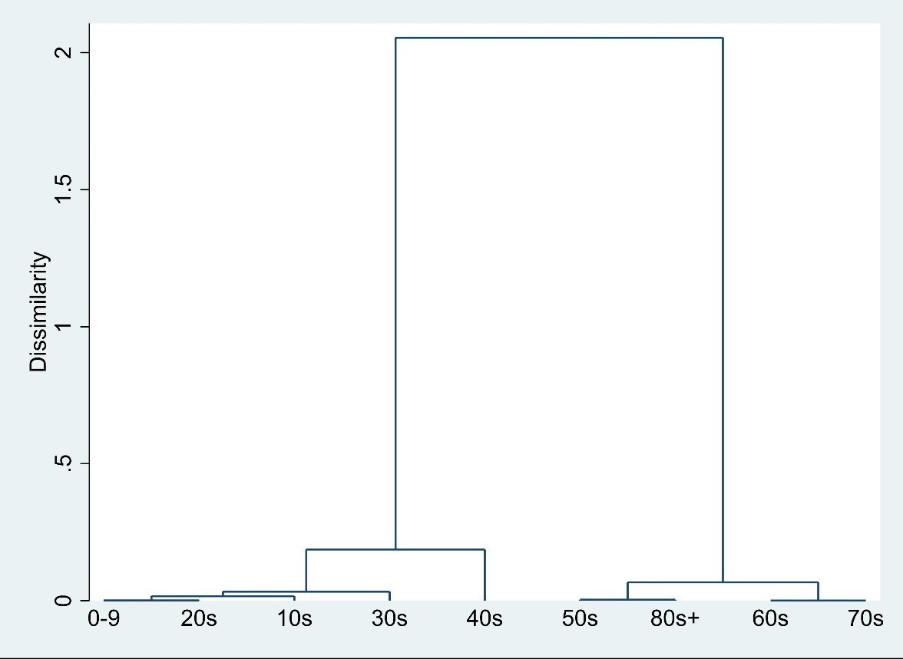

Figure 3 shows that for ‘very dissatisfied’, the 60s and 70s are similar, and 50s and 80s+ are also similar. These two clusters, 60s/70s and 50s/80s+ are also close in similarity and can be merged. On the other hand, 0-9 and 20s are similar. This is followed with the 10s close to this cluster of 0-9/20s, which is followed by the 30s. Since the dissimilarity between the 40s and 0 to 30s is large, the 40s could be considered independent.

Figure 4: Dendrogram for ‘Dissatisfied’ Cluster Analysis
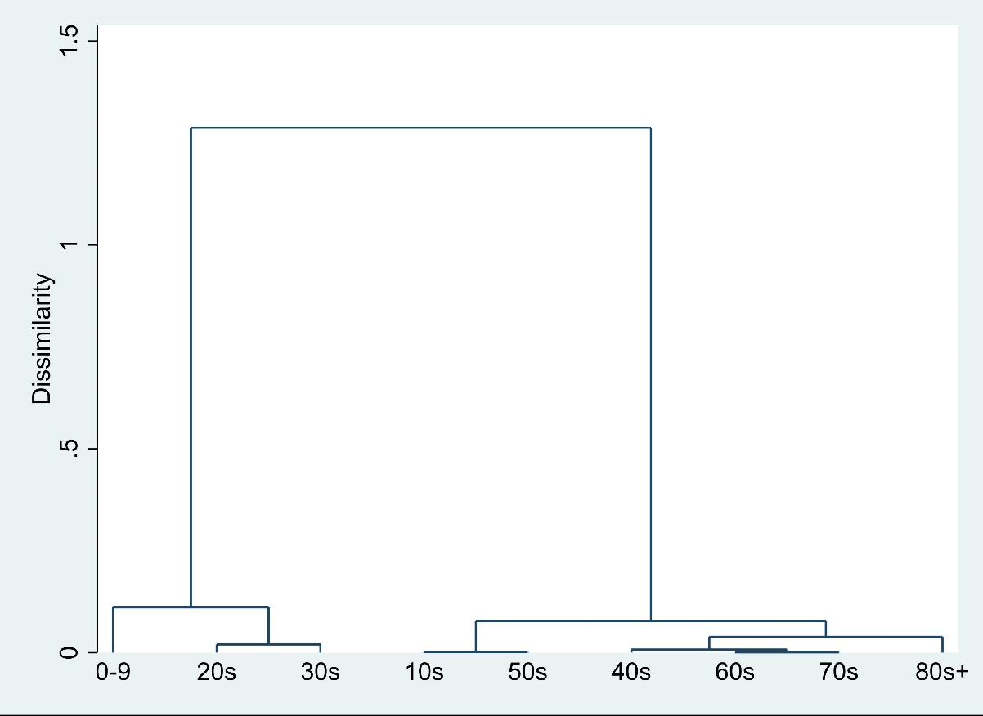

Next, with regard to ‘dissatisfied’, Figure 4 indicates that the 60s and 70s are similar, this can then be merged with the 40s and then the 80s+. 10s and 50s also have low dissimilarity which can be merged with the 40s/over 60s cluster. On the other hand, 20s and 30s are similar which can be merged with the 0-9. The dissimilarity between this cluster of 0-9 and 20s to 30s is large.

Figure 5: Dendrogram for ‘Very Dissatisfied’ Cluster Analysis
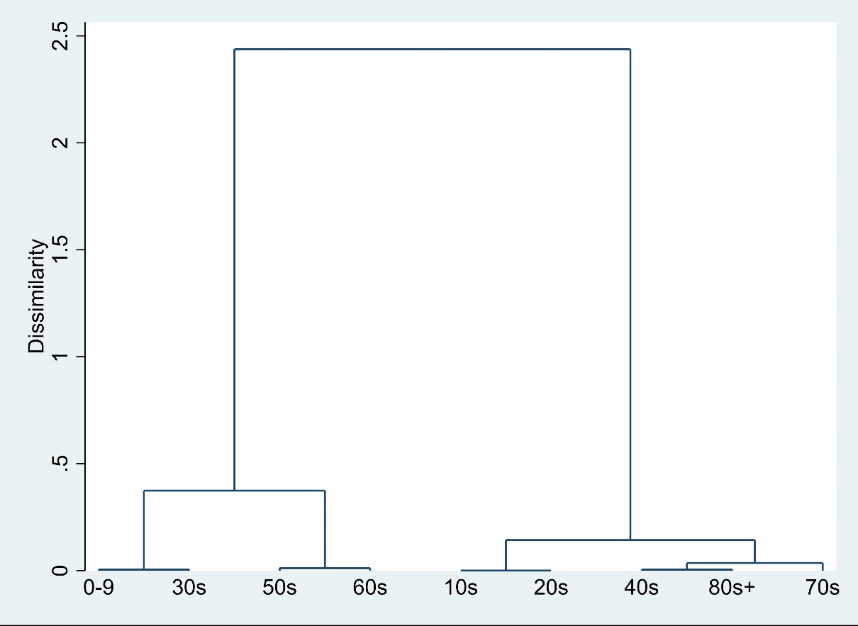

Finally, concerning ‘very dissatisfied’, Figure 5 shows that 0-9 and 30s, 50sand 60s, 10s and 20s, 40s and 80s+ are respectively similar. The 40s/80s+ can be merged with the 70s, which can then be merged with the 10s to 20s cluster. The dissimilarity between the 0-9 and 30s cluster with the 50s to 60s cluster is large.

DISCUSSION AND CONCLUSION

Tourism has a large impact on society and the economy and there is growing interest to understand the trend. Age is considered to have a large influence over human preference and is considered to impact tourists’ satisfaction. This research analyses the survey results concerning the tourists’ satisfaction of Japan domestic leisure travel with overnight stays to understand the characteristics of the age ranges in order to understand policy implications that any differences may have.
The results find that the younger age ranges tend to be more satisfied with their travel experience and the older age ranges tend to be dissatisfied. These results differ from past studies on tourism satisfaction where they found that younger people were less satisfied than older people (e.g. Sampol, 1996; Ryan, 1995; Kozak and Rimmington, 2000; Tsiotsou and Vasioti, 2006). This identifies the need for different strategies and approaches to cater for the difference in the age ranges. If we look at the results in more detail based on the degree of satisfaction, relative support for the two extremes of ‘very satisfied’ and ‘very dissatisfied’ show a large dispersity based on age range. The younger age ranges show stronger support for ‘very satisfied’. In order to maintain their high satisfaction even after the novelty of travel wears off, it will be necessary to provide rich content concerning travel ideas and suggestions so that they are able to continue to plan highly satisfying trips. This will likely require the active use of social media by the travel industry, since the younger generation are more reliant on social media (Ministry of Internal Affairs and Communications, 2018). If this level of satisfaction could be maintained, they are more likely to recommend destinations they have visited to their friends and relatives (Beeho and Prentice, 1997; Ross, 1993) and become loyal to the destination (Ramseook-Munhurrun et al., 2015). It may also affect the consumption of goods and services (Kozak and Rimmington, 2000).
Within the dissatisfied older age ranges, the 50s and 60s tend to be ‘very dissatisfied’. Wide negative feedback through social media and word of mouth could be damaging for the travel industry, since the spread of the negative communications is faster than those of positive communications (Cadotte and Turgeon, 1988; Lewis, 1983). Thus, it will be important to increase the communication with the tourists in this age range and for destination managers to review the performance against the 4C (customer value, customer cost, convenience and communication). On the other hand, the differences amongst the age ranges concerning ‘satisfied’ and ‘slightly satisfied’ are small, so it may not require a separate strategy or marketing plan as compared with the results of ‘very satisfied’ and ‘very dissatisfied’.
Conducting the analysis such as this to understand similarities between age groups concerning their satisfaction of their travel experiences could help guide future planning and development of travel related products, services and marketing. Such data based information could also be used to promote cooperation amongst the different stakeholders such as hotels, public transport, restaurants and the local government to develop data driven marketing strategies and improvements. This paper also provides opportunities for future research. Based on the understanding of the similarities concerning the satisfaction based on age groups, it would be beneficial to next analyse the factors that determine these results. For example, ‘Why is the ‘very satisfied’ results relatively driven by the younger age group and that relatively older age groups are less likely to be ‘very satisfied?’, ‘Does overnight travel impact the reason for the large amount of ‘very dissatisfied’ for the 50s and 60s?’ and ‘Why are the 40s near the average in their satisfaction?’. In order to understand these determining factors, further empirical and theoretical studies will be necessary. Furthermore, this paper covers overnight travels, so further analysis on the satisfaction of domestic leisure travel without overnight stays would be beneficial.

REFERENCES

Almanza, B. A., Jaffe, W., Lin, L. (1994), Use of the Service Attribute Matrix to Measure Customer Satisfaction. Hospitality Research Journal, 17 (2), 63-75.
Atami city (2018), Kanko no jittai to shiko (Current State of Tourism and Future Objectives). Available from:http://www.city.atami.lg.jp/_res/projects/default_project/_page_/001/005/973/20180727004.pdf (30.12.18) (in Japanese)
Baker, D.A., Crompton, J. L. (2000), Quality, satisfaction and behavioural intentions. Annals of Tourism Research, 27(3), 785–804.
Beeho, A. J., Prentice, R. C. (1997), Conceptualizing the Experiences of Heritage Tourists: A Case Study of New Lanark World Heritage Village. Tourism Management, 18 (2), 75-87.
Bernini, C., Cracolici, M. F. (2015), Demographic change, tourism expenditure and life cycle behaviour. Tourism Management, 47, 191-205.
Cadotte, E. R., Turgeon, N. (1988), Key Factors in Guest Satisfaction. Cornell Hotel and Restaurant Administration Quarterly, 28 (4), 45-51.
Chen, C.-F., Tsai, D. (2007), How destination image and evaluative factors affect behavioural intentions? Tourism Management, 28, 1115–1122.
Chi, C. G., Qu, H. (2008), Examining the structural relationships of destination image, tourist satisfaction and destination loyalty: an integrated approach. Tourism Management, 29, 624–636.
Chung, B., Hoffman, D. (1998), Critical Incidents. The Cornell Hotel and Restaurant Administration Quarterly, 39(3), 66-71.
Compo, S., Garau, J. B. (2008), The influence of nationality on the generation of tourist satisfaction with a destination. Tourism Analysis, 13(1), 81–92.
Crask, M. R. (1981), Segmenting the Vacationer Market: Identifying the Vacation Preferences, Demographics, and Magazine Readership of Each Group. Journal of Travel Research, 20(2), 29-34.
Development Bank of Japan, Japan Economic Research Institute Inc. (2017), Business travel market trend and future impact on the business travel industry. https://www.dbj.jp/ja/topics/region/industry/files/0000029022_file2.pdf (20.6.2018) (in Japanese)
Furuya, H., Nishi, K., Nose, M., Ge, W., Kim, H. (2008), Comparative analysis of tourism and travel behavior in Japan, China and Korea. Proceedings of Infrastructure Planning, 37. (in Japanese)
GF Ltd. (2011), Senir/korei-sha no ryoko nikansuru chosa (Study on the senior citizens travel). Available from: http://www.senior-promo.com/wordpress/wp-content/uploads/2011/06/senior_travel02.pdf (20.10.16) (in Japanese)
Hallowell, R. (1996), The Relationship of Customer Satisfaction, Customer Loyalty, Profitability: An Empirical Study. International Journal of Service Industry Management, 7 (4), 27-42.
Heung, V. C. S., Qu, H. Chu, R. (2001), The relationship between vacation factors and socio-demographic and travelling characteristics: the case of Japanese leisure travelers. Tourism Management, 22(3), 259-269.
Huh, J., Uysal, M., McCleary, K. (2006), Cultural/heritage destinations: Tourist satisfaction and market segmentation. Journal of Hospitality and Leisure Marketing, 14(3), 81–99.
Ito, K. (2016), Danjyo/nenrei-betu-kankokyaku no tokucho to sono suii – zenkoku-chosa to takayama-city kanko-tokei niyoru bunseki (Characteristics and Trend of Tourists based on Gender and Age – Examination of the National survey and Takayama city Tourism Statistics). Review of Economics and Information Studies, 16 (3/4), 41-62. (in Japanese)
Japan Tourism Agency (2017), Tourism-based Country Promotion Mater Plan. Available from: http://www.mlit.go.jp/common/000208713.pdf (10.12.2018) (in Japanese)
Johns, N., Gyimóthy, S. (2002), Market Segmentation and the Prediction of Tourist Behavior: The Case of Bornholm Denmark. Journal of Travel Research, 40(3), 316-327.
Jönsson, C., Devonish, D. (2008), Does Nationality, Gender, and Age Affect Travel Motivation? a Case of Visitors to The Caribbean Island of Barbados. Journal of Travel & Tourism Marketing, 25(3-4), 398-408.
JTB Corp. (2015), Ryoko-nenpo 2015 (Tourism Annual Report 2015). Available from: https://www.jtb.or.jp/wp-content/uploads/2015/10/nenpo2015_1-4.pdf (15.7.2018) (in Japanese)
Kawamura, S. (2008), Kankou keizaigaku no genre to ouyou (Principle and Application of Travel Economics). Fukuoka: Kyushu University Shuppankai.
Korzay, M., Alvarez, M. D. (2005), Satisfaction and dissatisfaction of Japanese tourists in Turkey. Anatolia: An International Journal of Tourism and Hospitality Research, 16(2), 176–193.
Kotler, P., Keller, K. L. (2010), Marketing Management. London: Pearson Education.
Kozak, M., Rimmington, M. (2000), Tourist Satisfaction with Mallorca, spin, as an Off-Season Holiady Destination. Journal of Travel Research, 38(3), 260-269.
Kuris, H. K., Bortoleto, A. P. (2011), Comparison of waste prevention behaviors among three Japanese megacity regions in the context of local measures and socio-demographics. Waste Management, 31(1), 1441-1449.
Lewis, R. C. (1983), When Guests Complain. Cornell Hotel and Restaurant Administration Quarterly, 24(2), 23-32.
Lieux, E. M. (1994), Lodging preferences of the senior tourism market. Annals of Tourism Research, 21(4), 712-728.
Ministry of Internal affairs and Communications. (2018), WHITE PAPER Information and Communications in Japan 2018. Available from: http://www.soumu.go.jp/johotsusintokei/whitepaper/ja/h30/html/nd142120.html (20.1.2018) (in Japanese)
Oppermann, M. (2000), Tourism destination loyalty. Journal of Travel Research, 39(1), 78–84.
Peter, L., Olson, J. L. (1987), Consumer Behavior: Marketing Strategy Perspectives. Burr Ridge, IL: Irwin.
Petrick, J. F., Tonner, C., Quinn, C. (2006), The utilization of critical incident technique to examine cruise passengers’ repurchase intentions. Journal of Travel Research, 44(3), 273-280.
Petrick, J. F. (2004), Are loyal visitors desired visitors? Tourism Management, 25(4), 463–470.
Pizam, A. (1994), Monitoring Customer Satisfaction, in: B. David and A. Lockwood (Eds.) Food and Beverage Management: A Selection of Readings. Oxford, UK: Butterworth-Heinemann, 231-247.
Prayag, G., Ryan, C. (2012), Antecedents of tourists’ loyalty to Mauritius: The role and influence of destination image, place attachment, personal involvement, and satisfaction. Journal of Travel Research, 51(3), 342-356.
Ramseook-Munhurrun, P., Seebaluck, V. N., Naidoo, P. (2015), Examining the Structural Relationships of Destination Image, Perceived Value, Tourist Satisfaction and Loyalty: Case of Mauritius. Procedia – Social and Behavioral Sciences,175, 252-259.
Rittichainuwat, B. N., Qu, H., Mongknonvanit, C. (2002), A Study of the Impact of Travel Satisfaction on the Likelihood of Travelers to Revisit Thailand. Journal of Travel & Tourism Marketing, 12 (2-3), 19-43.
Ross, G. F. (1993), Destination Evaluation and Vacation Preferences. Annals of Tourism Research, 20(3), 477-489.
Ryan, C. (1995), Learning about Tourists from Conversations: The over 55s in Majorca. Tourism Management, 16 (3), 207-215.
Sampol, C. J. (1996), Estimating the Probability of Return Visits Using a Survey of Tourist Expenditure in the Balearic Islands. Tourism Economics, 2 (4), 339-352.
Tsiotsou, R., Vasioti, E. (2006), Using Demographics and Leisure Activities to Predict Satisfaction with Tourism Services in Greece. Journal of Hospitality & Leisure Marketing, 14(2), 69-82.
Yoon, Y., Uysal, M. (2005), An examination of the effects of motivation and satisfaction on destination loyalty: A structural model. Tourism Management, 26(1), 45–56.

Konan University, Hirao School of Management, 8-33 Takamatsu-cho, Nishinomiya, Hyogo, Japan 663-8204; Corresponding author: ken_japan51@hotmail.com

