Analysis of Energy Intensity Decomposition in the Textile Industrial Sub Sector of Indonesia

**ABSTRACT**

The purpose of this study was to analyze the energy intensity decomposition in the textile industry subsector of Indonesia at level 2 and 3 KBLI. This is because of its usefulness in measuring energy efficiency. However, energy decomposition has not been able to accurately reflect the efficiency that occurs in the industrial sector. Since the results gotten from the calculation of energy intensity contains components of structural factors, there is need for the analysis of the changes in the composition of output caused by activities or a combination of output and energy intensity components. Energy intensity approach and the Time Series technique through the use of Log Mean Divisia Index (LMDI) I method was used in this study to determine the effect of structural and intensity factors on changes in aggregate energy intensity in the textile industry sector in Indonesia. The results showed that the energy intensity of the textile industry between 2006 and 2014 experienced a downward trend, but the structural factors were more dominant than the intensity factor. Therefore, there is need for structural factors in energy intensity decomposition of the textile industry sector so as to be able to save energy.

**Keywords**: energy intensity; structural effect; intensity effect: decomposition; textile industry; Indonesia

1. **INTRODUCTION**

The role being played by manufacturing industries in increasing the economic growth of Indonesia cannot be overemphasized. This can be seen from the contribution of this sector, with the exclusion of the oil and gas industry, to the *Gross Domestic Product* (GDP) of Indonesia from 2007 to 2015. It was recorded that the percentages for each year for the period stated were 22.43%, 13.00%, 12.57%, 21.55%, 18.13%, 17.99%, 17.72%, 17.87% and 18.18% respectively. This percentage is higher than other sectors that contribute to the economy such as agriculture, finance and services (Ministry of Industry, 2013 and 2016). It is also important to point out that this sector has experienced an insignificant increase in each year over time with 6.34%, 6.01%, 4.62%, 6.19%, 7.46%, 6.98%, 5.45%, 5.61% and 5.04% respectively (Ministry of Industry, 2013 and 2016).

The manufacturing sector in Indonesia consumes the highest quanity of energy compared to other sectors. From an analysis carried out on the rate of energy consumption in Indonesia between 2006 and 2011, the industrial sector ranked first followed by household, commercial and transportation sectors. The percentage of th energy consumed by the industrial sector over these periods are 43.33%, 44.83%, 43.23%, 44.22%, 41.09% and 43.97% respectively. In another analysis carried out for a period of four years, from 2012 to 2015, it was also discovered that the industrial sector ranked second after the transportation sector with a percentage of 39.58%, 31.29%, 31.69% and 35.07% respectively. (Pusdatin Ministry of Energy and Mineral Resources, 2016).

Energy is a scarcity commodity in terms of its supply. When comparing energy supply and energy needs, the industrial sector exceeds the available energy supply. In 2014, it was discovered that the electricity supplied could only meet 33% of the electricity demand and it has been predicted that it will reduce to 22% by 2020. The same thing is experienced in energy generated from gas and coal which is predicted to experience a decrease in its fulfillment from 80% for gas and 68% for coal in 2014 to 42% and 43% respectively by the year 2020 (Pusdatin of the Ministry of Industry, 2012). The industrial sector is dependent on energy which is increasingly diminishing. As a result of this scarcity of energy, the government needs to encourage the manufacturing industry sector to use enegry more efficiently through the use of energy utilization technologies in its production processes.

One of the ways to measure energy efficiency is through the use of energy intensity (Ang, 1987; Ang, Zhang and Choi, 1998). The smaller the value of energy intensity, the smaller the energy used in the production of a product or the more efficient a company uses its energy.

As a measure of energy efficiency, energy intensity cannot accurately reflect the efficiency of the industrial sector. This is because the results gotten from the calculation of energy intensity will be decomposed into components of structural factors that changes in the composition of output. Energy intensity is calculated from a combination of outputs and other energy components. Therefore, further research needs to be carried out on changes in energy intensity from one period to another so as to be able to separate efficiency of structural components through the use of decomposition techniques (Boyd, et al, 1987). As a result of this, in this study, decomposition of energy intensity was carried out using the Log Mean Divisia Index I (LMDI) method as done by Ang and Liu (2001), Ang (2004 & 2005), and Ma and Stern (2007). LMDI I method is the perfect method because it meets the requirements in terms of theoretical foundations (*reversal factor, time reversal, proportionality, and aggregation test)*, ability to adapt and the ease with which its results can be interpreted and used (Ang, 2004, 2005, 2008).

The study examined energy intensity and energy intensity decomposition in the textile industry sector with the data period from 2006 to 2014 through the use of LMDI I method. In addition, extensive decomposition calculations were carried out by disaggregating to the ISIC rev3 level. This is neccesary because the level of disaggregation affects the results of aggregate changes in energy intensity as illustrated in the results of research conducted by Ang (1987 and 1994), Boyd et al (1987), Lie, Sgrestha and Foell (1990), Ang, Liu and Ong (1991), Gardner (1993), and Sudhakara and Kumar (2010).

1. **LITERATURE REVIEW**
   1. **Production Function**

According to Jehle and Reni (2001), production processes are activities that convert input into output. The production function was formed in order to explain the mathematical relationship between the quantity of productive inputs and the quantity of output obtained at a particular period of time (Nicholson and Snyder, 2012). This function is represented with the following formula:

**………………… (1)

|  |  |  |
| --- | --- | --- |
| Q | = | Output |
| M | = | Raw material used |
| L | = | Labor input |
| K | = | Capital input |

This form of production function is **similar** to the one proposed by Cobb-Douglas:



* 1. **Cost Function**

Production costs are all expenses incurred by a company to obtain production factors and raw materials that will be used in the creation of goods. The total cost of production for a company for a specified period of time is represented as follows:

TC = wL + vK …………….(3)

The company needs to find the input combination to get the cheapest price combination, that is, when the marginal Rate of Technical Substitution (RTS) of L or K is equal to the input cost ratio ($w/v$). Nechyba (2017) states that the property of expenditure function in consumption theory is identical to the property of cost function in production theory. The cost function increases in the same direction as Q, if Q increases then TC will also increase (*marginal cost* is positive). The cost function does not decrease in the direction of the input prices, has one-degree homogeneity with *w* and forms concave towards *w* and *v*.

* 1. **Energy Intensity**

The cost function of corporate entities is influenced by economic changes. This includes changes in input prices, technological innovation and economic coverage (Nicholson, 2000). While modifying the production function, Eskeland and Harrison (2003) added energy inputs and technology index to get the equation below:

………………………. (4)

= Total output quantity of each industry/factory in *t* period

L = labor input in *t* period

K = capital input in *t* period

M = raw input in *t* period

E = energy input in *t* period

T = technology input in *t* period

In linear form, the production function becomes:

 ……………..….(5)

If both sides are divided by Yjt, the result obtained is as follows:

β4 (Tjt/ Yjt)

………….(6)

Equation 6 shows that Ejt/Yjt is the amount of energy used in the production of an output and it is referred to as **energy intensity**.

In the context of a country's aggregate, energy intensity is the amount of energy consumed with regards to the national output and it is represented with the following formula:

I = EC/PDB

Where,

I = energy intensity

EC = energy consumed at a specified period of time

PDB = domestic products at a specified period of time

From the corporate context, energy intensity is the amount of energy consumed per output of a company. The smaller the value of energy intensity, the smaller the energy consumed in the production of a product or, in other words, the more efficient a company uses its energy. The amount of energy consumption needed to increase one unit of output in a company can be measured using energy intensity. Therefore, energy intensity can used to measure energy efficiency (Ang, 1987, Ang, Zhang and Choi, 1998). Production factor (activity), intensity factor (efficiency), and structural factor have influence on the increase or decrease in energy intensity in the industrial sector. Structural factor is the change in energy used due to the composition of output from certain sectors, sub-sectors or industries caused by a combination of activities or a combination of products in such sectors, sub-sectors or industries (Nanduri, 1998). The decrease in energy intensity caused by a decrease in production in energy-intensive industries does not necessarily indicate that there is efficiency in the production process. It only indicates that there are changes in the composition of output in these sectors. The production factor (activity) is the change in total energy consumption that comes from changes in energy demand due to production activity. Therefore, increase in production does not mean there is efficient use of energy. Intensity factor is, therefore, the change in energy consumption as a result of the changes in efficiency, which occurs due to the use of technology that makes use of energy more efficiently.

* 1. **Energy Intensity Decomposition**

According to the Big Indonesian Dictionary (KBBI), decomposition is the process of changing a particular thing into a simpler form. Energy intensity decomposition has to do with breaking down of the calculation of energy intensity into several parts to include the effects of production, structural effects and intensity effects.

According to Ang (1995), there are three decomposition approaches that can be implemented and they are

1. Energy consumption approach

This approach calculates energy intensity decomposition by reducing the total energy consumed by the industrial sector in *t* period with the total energy consumed by the industrial sector in a zero period. The results will be divided into production, structural, and intensity factors. These three factors show the influence of changes in aggregate production, product mixture and energy intensity, in each sector, on the quantity of energy consumed.

1. Energy intensity approach

This approach calculates energy intensity decomposition by reducing the aggregate energy intensity in *t* period with the aggregate energy intensity in zero period. The results will be divided into structural factors and intensity factors.

1. Elasticity approach

This approach calculates energy intensity decomposition by comparing proportional changes in energy consumption with changes in total industrial production.

Dari tiga pendekatan dekomposisi dan dua jenis periode analisis di atas, maka jika tujuan dari penelitian adalah untuk menguraikan faktor struktural dan efisiensi, maka pendekatan intensitas energi dan teknik Time Series akan lebih tepat digunakan. Hal ini didukung dengan pendapat dari Ang (1995) yang menyatakan bahwa pendekatan intensitas akan lebih berguna jika tujuan penelitian adalah untuk mengetahui faktor struktural. Selain itu, jika pendekatan intensitas ini digunakan bersamaan dengan teknik *Time Series* akan menghasilkan interpretasi yang lebih mudah (Ang, 1994).

According to Ang (1995) there are two techniques that can be employed in determining the period to be analyzed: *Periodwise (PW) technique - Additive and Time series (TS) - Multiplicative*. Periodwise analysis uses the first and last year data for a specified period of time and describes how and why industrial energy consumption has changed over this time. Time series analysis, on the other hand, involves annual decomposition through the use of time series data and describes the effect of contribution of various factors on energy consumption over time.

From a proper analysis of the three decomposition approaches and the two types of analysis periods, it was discovered that the energy intensity approach and the Time Series technique were more appropriate for the purpose of this research. This is supported by the opinion of Ang (1995) which states that the intensity approach will be more useful if the purpose of the research is to find out structural factors. In addition, if this intensity approach is used in conjunction with the Time Series technique, it will produce easier interpretations (Ang, 1994).

* 1. **Disaggregation Level**

Disaggregation level of the industrial sector has to do with the data set of the industry on energy and production through which the industry will be divided into sub-sectors based on its activities. In determining the disaggregation level, the usual practice is to follow the *Standard Industry Classification* (SIC) based on energy usage pattern into energy-intensive and non-energy-intensive industries (Ang, 1995).

Determination of disaggregation level of the industrial sector is important in the calculation of the decomposition of energy intensity because of the effects of combination of activities or products in the sector, subsector or industry on the output produced. The variations in energy intensity are caused by structural factors at the level of the industry, some sectors and their sub-sectors as well as their relationship with the results of energy intensity decomposition. This is reinforced by the opinion of Ang, Liu, and Ong (1991) which states that in energy intensity research, there is need for the division of the industry into several sub-sectors because estimating the changes in the structural factor, when energy is being continually consumed, depends on the disaggregation level of the industrial sector. The same opinion was conveyed by Ang (1994), when he states that estimates of changes in structural effects for various levels of disaggregation could be different.

* 1. **Decomposition Technique**

The techniques commonly used in decomposition are Index Decomposition Analysis (IDA) and Structural Decomposition Analysis (SDA). The IDA technique basically includes two indices, which are *the Laspeyres (Paasche) Index* and *Divisia Index. The Laspeyres (Paasche) Index* is further divided into *the Laspeyres Index, Paasche Index, Fisher Ideal Index,* and *the Marshall-Edgeworth Index*. Divisa index is also sub-divided into *the Arithmetic Mean Divisia Index* (AMDI) and *the Logarithmic Mean Divisia Index* (LMDI) (Ma and Stern, 2007).

Ang and Liu (2007) state that the use of the *Laspeyers Index* produces a large residual and becomes a problem when interpreting the results and benefits of the calculations. However, the International Energy Agency has recommended *Laspeyres Index* when analyzing energy demand and intensity trends / energy efficiency.

*Divisia Index* was first carried by an economist from France named Francois Divisia (1889-1964). The application of this indexon energy intensity decomposition was first introduced by Boyd et al. (1987). *It* has to do with the weighted number of logarithms of growth rate, where the weight is part of the total value in integral form (Ang, 2004). It is mostly used by government / private institutions such as New Zealand, US Department of Energy, and European SAVE (Ang, 2004).

Like other indices, *Divisia Index* is also not free from residual values. However, the residuals it produces are smaller or close to zero when compared to those of *Laspeyers Index*. To overcome these residual values, Ang and Choi (1997) propose the use of *Refined Divisia Index*, where the results of the decomposition calculation do not produce residual values ​as a result of its *logarithmic mean weight function*. Ang and Choi (1997) prove that *Refined Divisia Index* solves problems that are related to zero value in the data used.

It is important to note that residual factors are unavoided factors during decomposition. Residual value is not part of structural factors and intensity and that is why it must be removed in order to have decomposition results that are not "*robust*". Some researchers have come up with different methods aimed at overcoming residual problems. Sun (1998) came up with a method called "*A Complete Decomposition Model*" using the concept of "*Jointly Created and Equally Distributed*". This method is identical to the *Shapley Decomposition Model* which was introduced by Albercht et al. (2002) and Ang (2004). In addition, Chung and Rhee (2000) also came up with "*Mean Rate of Change Index (*MRCI*)*" method. However, according to Lenzen (2005), the results cannot be separated from the existence of distortion under certain conditions. Of the various existing decomposition methods, LMDI I method is the perfect method for this research because it meets requirements in terms of theoretical foundations (*reversal factor, time reversal, proportionality, and aggregation test*), moreover, it has the ability to adapt, and its results are easy to use and interpret (Ang, 2004, 2005, 2008).

Evaluation and comparison of decomposition methods are as stated in the following table (Heinen, 2013):

|  |  |  |  |  |
| --- | --- | --- | --- | --- |
| **Table 1**  **Evaluation of decomposition methods** | | | | |
| **Index** | **Perfect Decomposition** | **Time reversible** | **Subsectors Additive** | **Easy to understand** |
| Paasche | No | No | Yes | Very easy |
| Simple Laspeyres | No | No | Yes | Very easy |
| Refined Laspeyres | Yes | No | Yes | Moderately |
| Fischer Ideal | Yes | Yes | No | Moderately |
| Simple average/arithmetic mean/divisia | No | Yes | No | Moderately |
| Adjusted PMD I and II | No | Yes | Yes | Difficult |
| LMDI I | Yes | Yes | Yes | Moderately |
| LMDI II | Yes | Yes | No | Moderately |

Source: Heinen (2013)

Ang, Zhang dan Choi (1998) applied *Logarithmic Mean Divisia Index* (LMDI) method in calculating energy decomposition and this was done through the following steps:

1. Energy consumption calculation

|  |  |
| --- | --- |
| Energy consumtion in certain *t* period: $E_{t}= \sum_{i=1}^{m}{E_{i,t}}$ …………………..(7) |  |

Et = totalenergy consumption of the industrial sector in *t* period

Ei,t = industrial *i* sector consuming energy in *t* period

1. Energy intensity calculation

Energy intensityfor sector*i*:

 ………………………(8)

Energy consumption in certain *t* period are explained with production and energy intensity.The production is calculated using the equation below

 ……… (9)

Ii,t = energy intensity of sector *i* in *t* period

Yi,t= industrial products of sector *i* in *t* period

1. Calculation Section/ industry products contribution

Section/ industry products contribution of sector*i* in *t* period:

 …………(10)

Yt= total industry production in *t* period

1. Energy consumption explanation

Energy consumtion in *t* period is explained throughenergy intensity, production, and energy contribution:



………………(11)

1. *Aggregate* energy intensity calculation

*Aggregate*energy intensity ${(I}_{t}$):

……(12)

1. Calculation of change in *aggregate* energy intensity

Change in *aggregate* energy intensity from zero to *t* period: $I_{tot}= \frac{I_{t}}{I_{0}}$……………….…..(13)

1. The calculation of Energy intensity decomposition

Change in *aggregate* energy intensity is decomposited through *multiplicative* approach:

 …………(14)

*DI int =* neutral intensity factor

*DI str =* structural factor

*DI rsd=* residual factor

1. Decomposition method formulation through divisia index

Decomposition method through divisia index to obtain an integrated 0 period to *t* period:

*Aggregate* energy intensity ${(I}_{t}$):……..(15)

1. Differentiation with respect to *t*and division of the two sides by $I_{t}$

 ……………(16)

1. Transformedto *ln* form

 ………..(17)

1. Intergration of period interval (0, *t*) will create a formula from divisia index:





Intensity changes from *t* time to *0* time as follows:

 …..(18)

The change caused by efficiency factoris shownas follows:

…………………..(19)

The change caused by structural factor is shown as follows:

…………………(20)

Residual is calculated from:

 ……………….………….(21)

1. Decompisition calculation with the use of LMDI I

Ang, Zang and Choi (1998) used*log mean weight*function, it is first introduced by Vartia (1974) and defined as follows:







Vartia (1974) used*aggregate value* where *the logarithmic mean of the factorial value* = , thus $w_{i}$ become:



Intensity change from *t* time to *0* time is:

…………(22)

The change caused by efficiency factor: ……………………..(23)

The change caused by structural factor: ………………..…..(24)

where

$w_{i}$ is*log mean weight function*introduced IDA by Ang and Choi (1997).

1. **DATA AND METHODOLOGY**

The data used in this study were gotten from the results of the Annual Survey of Processing Industry Companies conducted by the Central Statistics Agency (BPS) for the period of 2006 to 2014. ‘Data output’ were all products produced in the year concerned excluding goods that have not been processed (half-finished), goods that are not processed, and they were valued in Rupiah (thousands).

Energy consumption was stated in Oil Barrel Equivalent, which consists of Fuel (Gasoline / Premium / Gasoline, Solar / HSD / ADO / Diesel fuel / HSD / ADO, Kerosene / Kerosene, Coal / Coal, Gas from PGN / PGN Public, LPG excluding other fuels and lubricants) and electric power (PLN and Non-PLN)

In the calculation of energy intensity decomposition, the LMDI I method according to Ang, Zhang and Choi (1998) was applied using the following formula:

Intensity change from *0* time to *t* time:

$${TI}_{tot}= \frac{I_{t}}{I_{0}}=\exp\left\{\sum_{i=1}^{ m}{w_{i}\ln{\frac{I_{i,t}}{I_{i,0}}}} + \sum_{i=1}^{m}{w_{i}\ln{\frac{S_{i,t}}{S_{i,0}}}}\right\}$$

The change caused by efficiency factor:

$${DI}_{int}=\exp\left\{\sum_{i=1}^{ m}{w_{i}\ln{\frac{I_{i,t}}{I_{i,0}}}}\right\}$$

The change caused by structural factor:

$${DI}_{str}=\exp\left\{\sum_{i=1}^{ m}{w_{i}\ln{\frac{S_{i,t}}{S_{i,0}}}}\right\}$$

$$dimana w_{i}:$$

$${\begin{aligned} \\ = \frac{L (\frac{E_{i,t}}{Y_{t}} , \frac{E_{i,0}}{Y_{0}})}{L (I_{t} , I_{0 })}= \frac{(\frac{E_{i,t}}{Y_{t}}- \frac{E_{i,0}}{Y_{0}})/ (ln\frac{E_{i,t}}{Y_{t}}{-\ln{\frac{E_{i,0}}{Y_{0}} )}}}{(I_{t}- I_{0 })/ (ln I_{t}- ln I_{0 })}\end{aligned}}_{}$$

1. **RESULTS**

The resultwas divided into three sub-sections for discussion: energy intensity sector of textile industry, energy intensity decomposition sector of textile industry, and energy intensity dissagregation sector of textile industry.

* 1. **Energy intensity**

The results of energy consumption and output on textile industry from the year 2006 to 2014 are shown in the graph and tablebelow:

Table 2 textile industry (13)

Energy consumption and output

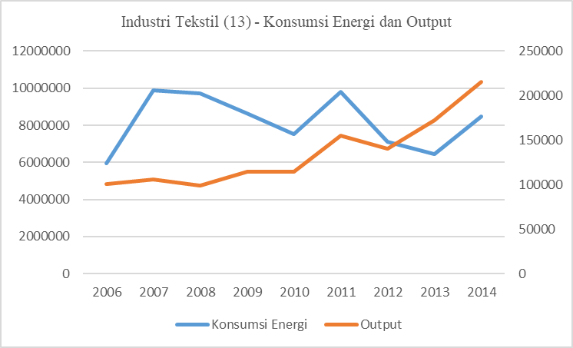

Source: BPS – re-processed Picture 1: textile industry (13) – energy consumption and

By researchers Output

In the textile industry, energy consumption trend and its output from the specified yearsare different related to the total manufacturingsector. It fluctuated between 2006 and 2014 by decreasing in the year 2007, increased in 2011, decreased again until 2014 when it started increasing. Meanwhile, the resulted output of the industry during this period is on the increaseexcept for between 2011 and 2012 where it witnessed a slight decline.

Industrial sector is a dominant sector when it comes to energy consumption in Indonesia in recent times. It has reached 49.9%of the total national energy consumption (Ministry of Energy and Mineral Resources, 2012). Textile industry, as a solid energy industry, is consuming around 70% of the total energy consumption in processing industry. Different sources of energy used in the textile industry are described in the graph below:

Picture 2 textile industry (13) – energy consumption per energy types

The picture 2 above shows that the type of energy that is most consumed by the textile industry is coal energy and PLN electricity. The use of coal energy in the textile industry is more prominent than the use of an electricity generator. The picture also shows that there are 7 types of industries that consume large quantity of energy both for use as fuel or as raw materials. These industries are steel industry, cement industry, fertilizer industry, ceramics industry, pulp and paper industry, textile industry and palm oil processing industry. When compared with other input factors, cost of energy in these seven (7) industries are even greater than labor costs, and are ranked second after the cost of raw materials (BPPT, 2013). When compared with other countries like India and Japan, energy consumption in the steel and textile industries is not efficient.

The resuls gotten from the calculation of energy intensityin the textile industry for the period of 2006-2014 is as shown in the table and figure 3 below:

Table 3 Textile Industry (13) -

Energy Intensity

(SBM / Billion Rupiah)

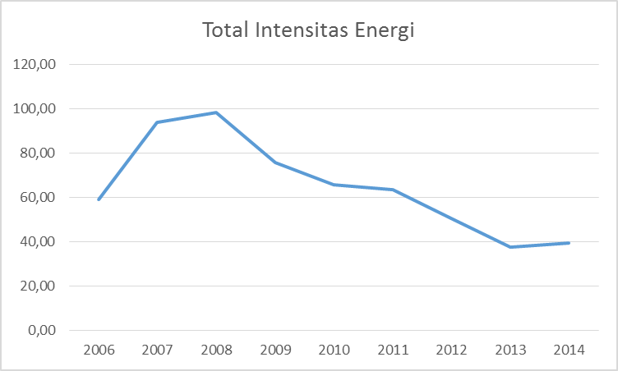

Source: BPS – re-processed Picture3textile industry (13) – energy intensity

by researcher

In the textile industry, there was increase in the energy intensity from 2006 to 2008 from 59.08 SBM/Billion Rupiah to 98.28SBM/Billion Rupiah and then there was a significant decrease from year to year. Year 2013 experiencec the lowest point at 37.40 SBM/Billion Rupiah before a little increment to 39.50 SBM/Billion Rupiah in the year 2014. There is, therefore, the need to explored the significant reduction in energy intensity in the textile industry based on structural factors and intensity (efficiency).

* 1. **Decomposition of Energy Intensity in the Textile Industry Sector**

Changes in aggregate energy intensity in the textile industry from year to year show a decrease except for the period of 2010-2011 and 2013-2014, as shown in the following table:

Table 4 Textile Industry (13) - Decomposition

Energy Intensity

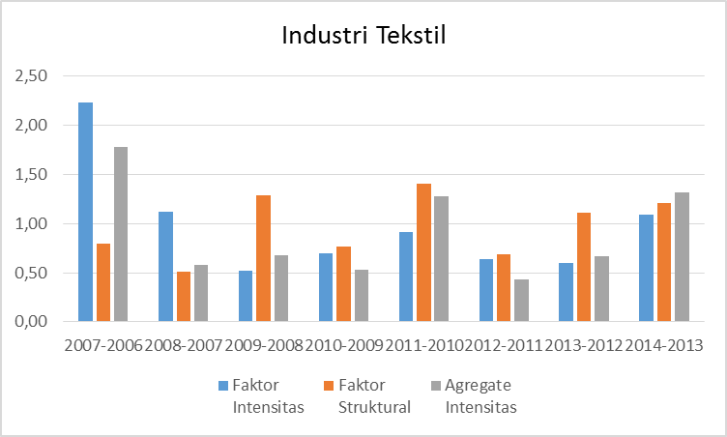

Source: BPS – re-processed by researcher Picture 4 textile industry (13) – decomposition

In the textile industry, the effect of structural energy on aggregate energy intensity is more dominant than that of intensity factors except for 2006-2007 and 2007-2008 periods where the intensity factor dominated. This shows that most textile industries have not made significant improvements toward energy efficiency. The government has come up with various efforts towards increasing the competitiveness of the textile industry by issuing Government Regulation No. 28 of 2008 concerning National Industrial Policy. This regulation regulates policies related to the textile industry by carrying out restructuring and modernization of the Textile and Textile Products (TPT) machinery industry. Another effort of the government towards the encouragement domestic textile industry growth was carried out by the Ministry of Industry through implementation of a revitalization program of textile and textile products (TPT) machinery and equipment, a decrease in electricity prices for the textile industry, and the provision of special incentives in the form of energy refund programs to boost exports of the textile industry and textile products (TPT). It is, however, important to point out that these efforts and policies have not been effective.

* 1. **Energy IntensityDisaggregation in the Textile Industry Sector**

A deeper analysis of disaggregation in the textile industry sub-sector at the ISIC level 3 was carried out to determine how the disaggregation of the textile industry sector affects the structural and intensity factors. At the ISIC level 3, the textile industry was divided into the Spinning Industry, Textile Weaving and Finishing (131) and Other Textile Industries (139).

1. Spinning Industry, Textile Weaving and Finishing (131)

In the spinning industry, weaving and textile finishing (131), the effect of structural factors are seen on the aggregate energy intensity. It is more dominant than the aggregate factor of intensity from the period of 2008-2009, 2010-2011, 2011-2012, 2012-2013 and 2013-2014, as shown in the picture below:

Table 5 Spinning Industry, Weaving

and Textile Settlement (131)) -

Decomposition

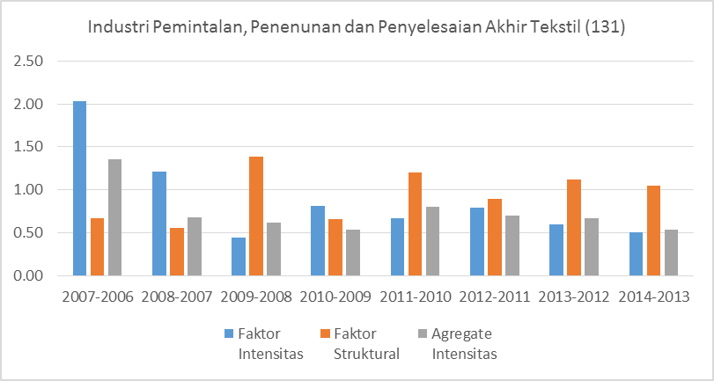

Source: BPS – re-processed by researcher Picture 5 Spinning Industry, Textile Weaving and Finishing (131)

1. Other Textile Industries (139)

In the Other Textile Industry (139), structural factors also have effect on the aggregate energy intensity and it is more dominant in the period between 2009-2010, 2011-2012, 2012-2013 and 2013-2014, as shown in the figure below:

Table 6 Other Textile Industries (139) -

Decomposition

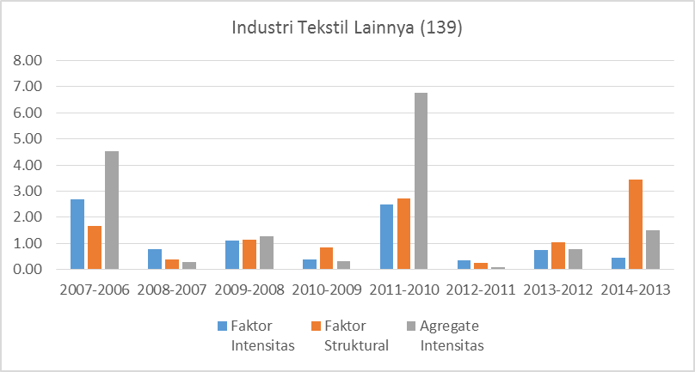

Source: BPS – re-processed by researcher Picture 5 Spinning Industry, Textile Weaving and Finishing (131)

From the results gotten from the calculation of energy intensity for the period of 2006 to 2014, it appears that there is a continuous decrease in the energy intensity of the textile industry from 2008 to 2014. Energy intensity change in the aggregate textile industry from year to year shows that structural factors influence aggregate energy intensity andthat it is more dominant than the intensity factor. From a deeper analysis of disaggregation in the textile industry sub-sector at the ISIC 3 level of the Spinning Industry, Weaving and Textile Finishing (131) and Other Textile Industries (139), it was discovered that structural factors also influence the aggregate energy intensity that is more dominant.

1. **CONCLUSION**

The industrial sector, especially the textile industry, is the most sensitive sector to the economic growth of Indonesia and it has caused an increase in energy demand. From the results of this study, it can be concluded that the textile industry is wasteful in energy consumption. The existing policies of the government have not been able to encourage textile industry players to make efficient use of energy until 2014. Since 2014, a number of government policies relating to the textile industry has been implemented. These policies include energy refund program, deregulation of some regulations to support the textile industry, drafting of a wage system to ensure certainty for workers and businesses, decrease in gas prices, delay in electricity bill payments for industry, development of a bonded logistics center and encouragement of entrepreneurs to diversify their products so as to meet fashion needs. Most of these policies have been discovered to be inefficient in the management of energy consumption.

**REFERENCES**

Ang B.W., 1987, Structural change and energy demand forecasting in industry with applications to two newly industrialized countries, *Energy,* Vol 12 (2), pp 101-111.

Ang B.W, (1994), Decomposition Of Industrial Energi Consumption: The Energy Intensity Approach, *Energy Economy Journal*, 16 (3) 163-174

Ang B.W (1995), Multilevel Decomposition Of Industrial Energy Consumption. *Energy Economic*, Vol. 17, (1), p. 39-51, 1995

Ang B.W (1995), Decomposition Methodology In Industrial Energy Demand Analysis, *Energy Journal. Energy* Vol. 20, (1) I, pp. 1081-1095. 1995

Ang B.W (2004), Decomposition analysis for policymaking in energy: which is the preffered method? *Energy Policy* 3 (2) 1131–1139

Ang B.W (2005) The LMDI approach to decomposition analysis: a practical guide*.* *Energy Policy* 3 (3). 867-871

Ang B.W (2008) *Index Decomposition Analysis Using LMDI: A Simple Guide*. Department of Industrial & Systems Engineering (ISE) National University of Singapore. January 2008.

Ang B. W., Liu, X. Q., And Ong, H. L., (1992) Sector Disaggregation and The Effect of Structural Change on Industrial Energy Consumption. *Energy* Vol. 17, (7), pp. 679-687

Ang B.W. and Liu, F.L. (2001), A new energy decomposition method: perfect in decomposition and consistent in aggregation. *Energy* 26, 537–548

Ang B.W. and Liu, Na. (2007), Negative-value problems of the logarithmic mean Divisia index decomposition approach. *Energy Policy* 35, 739–742

- Ang B.W (2007) Energy decomposition analysis: IEA model versus other methods. *Energy Policy* 35, 1426–1432

Ang B.W. and Lee S. Y. (1994), Decomposition Of Industrial Energy Consumption: Some Methodological And Application Issues, *Energy Economy Journal*, 16 (2) 83-92

Ang, B W and Skea, J F. (1994). Structural change, sector disaggregation and electricity consumption in the UK industry. *Energy and Environment*, 5 (1) 1-16

Ang, B.W. and Zhang, F.Q. (2000). A survey of index decomposition analysis in energy and environmental studies. *Energy* 25, 1149–1176

Ang, B.W. and Zhang, F.Q. and Choi Ki-Hong. (1998). Factorizing changes in energy and environmental indicators through decomposition. *Energy* 23 (6), p 489 – 495

Central Body of Statistic (2009).*Peraturan Kepala Badan Pusat Statistik No.57/2009 tentang Klasifikasi Baku Lapangan Usaha Indonesia.* Cetakan III

Central Body of Statistic (2013). *Berita Resmi Statistik*, No. 14/02/Th.XVII, 3 Pebruari 2014 diunduh dari www.bps.go.id/brs_file

Central Body of Statistic (2014). .*Berita Resmi Statistik*, No. 12/02/Th.XVI, 1 Pebruari 2013 diunduh dari www.bps.go.id/brs_file

Balai Besar Teknologi Energi Badan Pengkajian dan Penerapan Teknologi, (2012), *Perencanaan Efisiensi dan Elastisitas Energi* diunduh di website www.bppt.go.id

Biro Perencanaan Kementerian Perindustrian Republik Indonesia, (2012) *Perencanaan kebutuhan energi sektor industri dalam rangka akselerasi industrialisasi.*

Biro Perencanaan Kementerian Perindustrian Republik Indonesia, (2017), *Perencanaan kebutuhan energi sektor industri dalam rangka akselerasi industrialisasi.*

Boonkham and Leeprechanon, (2015),. *Decomposition Analysis of Changes in Energy Intensity of The Thai Manufacturing Sector during 1991-2013*. International Journal of Materials, Mechanics and Manufacturing, Vol. 3, No. 3, August 2015

Bor, Yunchang Jeffrey. (2008), *Consistent multi-level energy efficiency indicators and their policy implications*. Energy Economics 30 (2008) 2401–2419

Boyd, G, McDonald, J F, Ross, M and Hanson, D A, (1987*), Separating the changing composition of US manufacturing production from energi efficiency improvements: a Divisia index approach* *The Energi Journal*, 8 (2) 77-96

Boyd, Gale A., Hanson, and Sterner, Thomas (1987), *Decomposition of changes in energi intensity: A comparison of the Divisia index and other methods*

Can Stephane de la Rue du and Sathaye Ali Hasanbeigi Jayant, (2011) A*nalysis of the Energy Intensity of Industries in California*

Chung Hyun-Sik and Rhee Hae-Chun (2001). *A residual-free decomposition of the sources of carbon dioxide emissions: a case of the Korean industries.* Energy 26 (2001) 15–30

Debertin, David L., (2012). *Apllied Microeconomic: Consumption, Productions and Market*., Second Edition

Eskeland, Gunnar S., and Harrison, Ann E., (2003), *Moving to greener pastures? Multinationals and the pollution haven hypothesis*. Journal of Development Economics 70 (2003) 1–23

Greene, William H. (2012), *Econometric Analysis*, Pearson International Edition. 7th ed

Gujarati, Damodar N., (2007), *Dasar-dasar Ekonometrika*, edisi ketiga, Penerbit Erlangga

Gujarati, Damodar N., (2012), *Basic Econometric,*Fourth Edition

Hoekstra, Rutger and van der Bergh, Jeroen J.C.J.M., 2003. *Comparing structural and index decomposition analysis*. Energy Economics 25 (2003) 39–64

Huang, Jin-ping, (1993),  *Industry energy use and structural change: A case study of The People’s Republic of China*

Inglesi-Lotz R and Pouris A. (2012). *Energy efficiency in South Africa: A decomposition exercise.* Energy 42 (2012) 113e120

Lenzen, Manfred., (2006). Decomposition analysis and the mean-rate-of-change index*.* *Applied Energy* 8 (3), 185–198

Nanduri, Mallika., (1998), *An assessment of energi intensity indicators and Their role as policy - making tools,* School of Resource and Environmental Management Simon Fraser University

Nechyba, Thomas J. (2017), *Microeconomics: An Intuitive Approach with Calculus*., 2nd edition

Nicholson Walter and Snyder Christopher. (2012). *Microeconomic Theory: Basic Principles and Extensions*., 11th edition

Nicholson Water., (2000) *Intermediate Microeconomics: and Its Application*., 8th edition

Prasetio, Heru and Sorapipatana, Chumnong. (2013*). A Decomposition of Changes in the Energy Consumption of theIndonesian Manufacturing Sector during 1990-2008. Journal of Sustainable Energy & Environment* 4 (4), 95-102

Reddy B. Sudhakara and Ray, Binay Kumar, (2010). Decomposition of energi consumption and energi intensity in Indian manufacturing industries. *Energy for Sustainable Development*, 14 (2), 35–47

Sun, J.W., (1998), *Changes In Energy Consumption And Energi Intensity: A Complete Decomposition Model*, Turku School of Economy, Finland. Energy Economics 20, 85-100.

Wood, Richard and Lenzen, Manfred.,2006. *Zero-value problems of the logarithmic mean divisia index decomposition method*. Energy Policy 34 (2006) 1326–1331

Worrell, Ernst., Price, Lynn., Martin, Nathan., Farla, Jacco, and Schaeffer, Roberto., (1997). Energy intensity in the iron and steel industry: a comparison of physical and economic indicators.  *Energy Policy*, Vol. 25, Nos. 7-9, pp. 727-744.

World Bank, (2010). Global Industrial Energi Efficiency Benchmarking - An Energi Policy Tool. *Working Paper*

World Bank., (2011), Energi efficiency in developing countries for the manufacturing sector*.Working Paper*