Visualising the Global Shift in Energy Demand and Supply

Muhammad Isma’il
Department of Geography, Ahmadu Bello University, Zaria.
P.M.B. 1069, Zaria, Nigeria. Phone: +2347054878690, +2348067397345.
E-mail: mgeogjameel@yahoo.com

ABSTRACT: The global energy demand depends on supplies from fossil fuels responsible for climate change. The supply of the fossil fuels required to meet the global energy demand depends on production from the available proved reserves of oil, coal and gas unevenly distributed around the world. On the other hand, the energy demand of a country is determined by its economic growth and population dynamics. The industrialised nations accounted for the rising demand in global primary energy. However, a global shift is underway with the developing economies being responsible for most of the increase in global energy demand. Moreover, statistics suggest that the global energy production and consumption vary spatially and temporally. This study utilised cartograms to visualise the global shift in production and consumption of fossil fuels; because of its implication on global energy security and climate change. We observed that cartograms which are rarely used in energy visualisations provide informative and intuitive picture of the global shift in energy demand and supply.

Keywords: Energy consumption; Energy production; Energy security; Fossil fuels.
JEL Classifications: Q4; Q41

1. Introduction
The global energy demand depends on supplies from the fossil fuels responsible for climate change. Fossil fuels account for 80.9% of global primary energy supply and is predicted to account for 80% of fuels by 2030 (International Energy Agency (IEA, 2009), Energy Information and Administration (EIA, 2010)). Oil’s share of the global primary energy supply is the greatest. In spite of minor fluctuations in supply, oil accounts for 30% of global primary fuel mix in 2030 (IEA, 2009: 42). The total primary energy demand of a country is determined by its economic growth, population change and level of industrialisation. The industrialised nations accounted for the rising demand in global primary energy. However, statistics from the IEA (2009), EIA (2010) and World Development Indicators (WDI) (World Bank, 2010) suggest that there is shift in this trend with the developing economies being responsible for most of the increase in global energy demand. In order to sustain the rising economic growth and population increase among countries of the world, we need to ensure security of energy supplies. Energy security according to the IEA implies “adequate, affordable and reliable supplies of energy” (IEA, 2007: 160). The supply of the fossil fuels required to meet the global energy demand depends on production from the available proved reserves of oil, coal and gas unevenly distributed around the world. The amount of energy supplied into the world market is not directly proportional to the quantity of proved reserves but influenced by other socioeconomic factors. Understanding the geographies of energy production and consumption as well as the spatial variation in energy supply and demand is critical not only in our quest for alternative sources of fuel but also in global environmental change studies. In addition, this will help in spatial analysis of the flow patterns of energy commodities which have implication on economic globalisation. This research aims to develop new ways of visualising the global shift in energy demand and supply using cartograms which are rarely used in energy studies.

1.1 Energy Terms and Concepts
Primary Energy consists of oil, natural gas, coal/peat, nuclear, hydro and others (IEA, 2009). In this study, energy production and energy supply are used interchangeably, just as energy demand and energy consumption.
Energy consumption implies Total Primary Energy Supply (TPES) which “is made up of production + imports – exports – international marine bunkers – international aviation bunkers ± stock changes. For the world total, international marine bunkers and international aviation bunkers are not subtracted from TPES” (IEA, 2009: 63).
Peak oil refers to “an impending, permanent decline in the production of so-called ‘conventional’ oil as geophysical limits on its availability begin to bite” Bridge (2010: 523).
OECD: Organisation for Economic Cooperation and Development. It includes OECD Europe, OECD North America and OECD Pacific regional groupings.
1.2 Energy Scenarios
Scenarios are useful scientific tools which provide alternative futures. They enhance our understanding of complex systems behaviour. The scenarios provide projections which are crucial for visualising and analysing the dynamics as well as the future trends of global energy system. The projections in each scenario are based on assumptions about such factors as population growth, macroeconomic trends, energy prices, technological developments and government policies. Although there are uncertainties associated with these factors that drive energy demand and supply (IEA, 2009), they provide alternative futures not far from reality.
EIA Reference Case Scenario
The EIA Reference Case “reflects a scenario in which current laws and policies remain unchanged throughout the projection period” [7 pp. 1].
IEA Scenarios - The IEA has two projections:
- Reference Scenario (based on current policies) which provides a baseline picture of how global energy markets would evolve if governments make no changes to their existing policies and measures (IEA, 2009).
- 450 Policy Scenario (based on policies under consideration) which depicts a world in which collective policy action is taken to limit the long-term concentration of greenhouse gases in the atmosphere to 450 parts per million of CO₂-equivalent (ppm CO₂-eq), an objective that is gaining widespread support around the world” (IEA, 2009: 41).
The last part of this section reviews relevant literature. Section two consists of the materials and methods which outline the types of data used as well as the visualisation approach employed. Section three presents the results and discussion on the geography of oil demand and supply, analysis of coal demand and supply, as well as visualising gas production and consumption. This is followed by conclusion.
1.3 Literature Review
Industrialisation, economic and population growth are the driving forces of the increasing demand for primary energy especially among the developing economies. Statistics from British Petroleum (BP, 2009), IEA (2009), EIA (2010) and World Bank (2010) show the industrialised nations as the biggest consumers of energy as a result of their economic growth and technological development. But this trend has shifted, with the developing economies accounting for most of the increase in global energy demand. In fact, about 90% of the increase in global primary energy demand between 2007 and 2030 is projected to come from developing economies (IEA, 2009, World Bank, 2010).
The BP Statistical Review of World Energy (2009) reported an unprecedented primary energy demand among non-OECD (Organisation for Economic Cooperation and Development) countries higher than the OECD demand in 2008. The IEA’s reference case predicts a 40% increase in global energy demand between 2007 and 2030; while the EIA’s reference case predicts that between 2006 and 2030, non-OECD energy demand will increase by 73% compared with a 15% increase in energy consumption among the OECD countries. Although the percentage of increase in global energy demand varies in both scenarios, they however agree that China and India remain the major consumers. Bradshaw (2010: 279) observed that: “in a relatively short period of time there has been a dramatic shift in global energy demand and all of the indications are that this pattern is set to continue.” He concludes that this geography of new demand growth will have a serious implication on energy trade and will also result in substantial new financial flow patterns between energy producers and consumers. Understanding this trend is critical because of its implication on global energy security, economic globalisation and climate change.
Bradshaw (2010) briefly highlighted the geography of energy demand and its implication on economic globalisation and climate change. Podobnik (2006) investigated the patterns in the extraction and consumption of primary energy resources, with more emphasis on production and little highlight into the future. Energy production and consumption is a dynamic process, just as historical analysis of global energy shifts by Podobnik (2006) revealed that in about fifty to sixty years, entirely new systems of energy production and consumption have continually enveloped the world. There is therefore the need to visualise the future trend of the global energy system so as to plan for its consequences. Aleklett et al (2010) analysed the world oil production Reference Scenario in World Energy Outlook 2008. This research utilises cartograms to represent the global shift in energy demand and supply as a dynamic process, visualising from present into the future.

2. Material and Methods
2.1 Data used are historical, current and projections on:
1. Global oil, gas and coal production
2. Global oil, gas and coal consumption
3. IEA and EIA Scenarios
2.2 Data sources
The following provide comprehensive current data and projections.
1. British Petroleum (BP) Statistical year book, 2010 (plus historical dataset)
2. Energy Information Administration (EIA/ (IEO) Report, 2010
3. International Energy Agency (IEA) World Energy Outlook, 2009
4. IEA Key World Energy Statistics, 2009
5. World Resources Institute’s (WRI) Climate Analysis Indicators Tool (CAIT)
6. World Development Indicators (WDI), 2009.
7. International Panel on Climate Change (IPCC) Report, 2007
Energy and climate change data are usually reported at national or regional scales. The EIA regional grouping is adopted because it consists of all the key players in global energy security. The grouping is shown in table 1 below:

Table 1. Regional grouping used in the visualisation
Organisation for Economic Cooperation and Development (OECD) | Non-OECD
OECD North America | Non-OECD Europe/Eurasia
U.S.A | Russia
Canada | Other
Mexico | Non-OECD Asia
OECD Europe | China
OECD Asia | India
Japan | Other Non-OECD Asia
S. Korea | Middle East
Australia/New Zealand | Africa
 | Central and South America
 | Brazil
 | Other C. and S. America

2.3 Visualisation Approach: Cartograms
A cartogram is a map which presents the shape of each region according to an attribute value. This study developed cartograms to visualise the spatial distribution of energy producers and consumers. The ArcGIS Cartogram Geoprocessing Tool (version 2), developed by Tom Gross, that uses the Gastner and Newman (2004) cartogram algorithm generated the cartograms. The ArcGIS Cartogram Geoprocessing Tool has the advantage of shorter processing time (Andresen et al, 2009). The objective of creating cartograms is to rescale each region according to the value of the variable of interest while keeping the map recognizable, as much as possible (Henriques et al (2009). Although area-preserving projection (planimetric maps) provides an intuitive representation of spatial information, they could be misleading because attention may be focused on areal units irrespective of populations (Dorling, 1996) making cartograms better alternatives. The academic research involving the use of cartograms has focused on politics and epidemiology (Dorling, 1996, Andresen et al, 2009). Cartograms are also used in mapping mortality (Dorling, 1996). Andresen et al (2009) illustrate how the use of cartograms in crime mapping provides a significant amount of additional spatial information over planimetric-choropleth maps. The use of cartograms in energy analysis is extremely rare in spite of their intuitive power in highlighting spatial variations. This project used cartograms to map the global change in energy production and consumption as a dynamic process.

3. Results and Discussion
3.1 The geographies of oil production and consumption
About 30 percent of global primary energy supplies between 2007 and 2030 come from oil (IEA, 2009, EIA, 2010). Oil remains the single most important though environmentally dangerous source of global energy. Figures 1A and 1B show the spatial distribution of the oil producers and consumers respectively. Although, the spatial arrangement in the former is determined predominantly by natural factors and mostly cultural factors in the latter, it has implication on global energy security. For instance, in 2008, the Middle East produced 31.9% percent of the global oil and consumed only 7.8% of the global oil. On the other hand, the United States’ share of total production was 7.8% and 22.5% as share of oil consumption as highlighted in table 2. The table reveals the kind of disparity in the spatial distribution of those who produce oil and those who consume it. Figure 1A indicates that major producers of oil in 2008 are Saudi Arabia and Russia while figure B shows that the major consumers are United States and China.
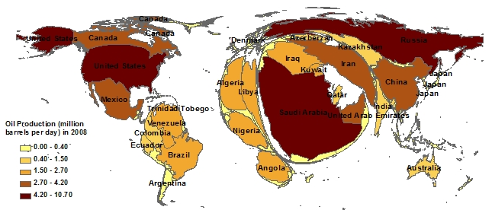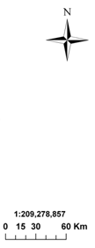
Figure 1A. Oil Producers in 2008
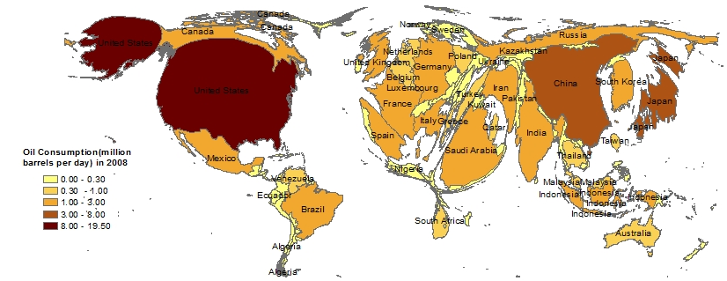
Figure 1B. Oil Consumers in 2008

Table 2. Regional Shares of Global Oil Production and Consumption in 2008
Region | Oil Production (2008 Share of total) | Oil Consumption (2008 Share of total)
United States | 7.8% | 22.5%
Total North America | 15.8% | 27.4%
Brazil | 2.4% | 2.7%
Total S. & Cent. America | 8.5% | 6.9%
United Kingdom | 1.8% | 2.0%
Russian Federation | 12.4% | 3.3%
Total Europe & Eurasia | 21.7% | 24.3%
Saudi Arabia | 13.1% | 2.7%
Total Middle East | 31.9% | 7.8%
Total Africa | 12.4% | 3.4%
India | 0.9% | 3.4%
China | 4.8% | 9.6%
Total Asia Pacific | 9.7% | 30.1%
Note: Adapted from BP Statistical Review of World Energy, 2009.

Statistics from EIA (2010) show that by 2030, the geographies of oil demand and supply as represented in figures 1A and 1B will change. The changes are significant in both geographies as depicted in table 3. This shift in oil supply and demand is represented in figures 2A and 2B.
Figure 2A shows that on a regional basis, the Middle East remains the dominant source of global oil. Its share of the total global production is 31.5%, as outlined in table 3. However, this has fallen by 0.4% from its share of production in 2008. This is followed by North America. Although United States’ share of production rises in 2030, her consumption falls. Table 3 also shows that while China’s share of production falls, her consumption rises. This is expected because of economic and population growth. On the other hand, the demand of Non-OECD Asia has surpassed that of OECD North America as shown in table 3. Based on 1% per year growth in production over the projection period; the IEA Reference Scenario projects an increase in oil demand from 84.7 million barrels per day (mb/d) in 2008 to 105.2 mb/d in 2030.
Although cartograms are intuitive in representing dynamics of geographic phenomena, they are sometimes misleading. For instance, in showing regional energy consumption for OECD Europe as depicted in figure 2B, a disproportionate share is given to Iceland because it is geographically detached from the region.

Figures 2A and 2B present the oil production and consumption scenarios in 2030
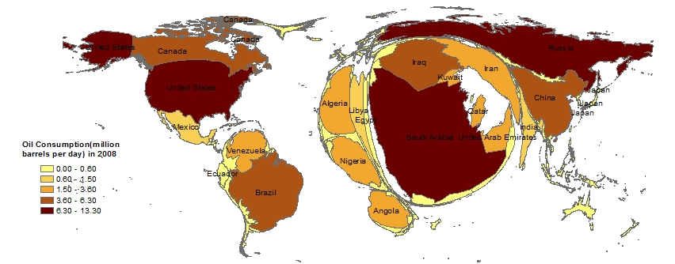
Figure 2A. Oil Producers in 2030
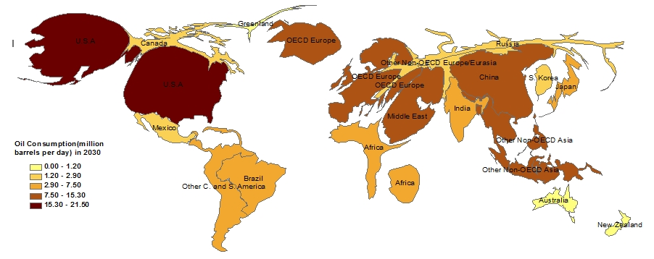
Figure 2B. Oil Consumers in 2030

Table 3. Regional Shares of Global Oil Production and Consumption in 2030
Region/Country | Oil Production | Oil Consumption
OECD
OECD North America | 17.6% | 25.4%
United States | 10.4% | 20.7%
OECD Europe | 2.5% | 13.1%
OECD Asia | 0.7% | 7.9%
Japan | 0.1% | 4.1%
Total OECD | 21.0% | 46.5%
Non-OECD
Non-OECD Europe and Eurasia | 15.7% | 4.9%
Russia | 11.4% | 2.6%
Other | 4.4% | 2.3%
Non-OECD Asia | 7.6% | 28.0%
China | 4.5% | 14.7%
India | 1.1% | 4.1%
Other Non-OECD Asia | 2.0% | 9.1%
Middle East | 31.5% | 9.1%
Africa | 12.8% | 4.0%
Central and South America | 11.3% | 7.2%
Brazil | 6.1% | 3.5%
Other Central and South America | 5.2% | 3.7%
Total Non-OECD | 79.0% | 53.5%
Adapted from Energy Information Administration / International Energy Outlook 2010

Figures 1A and 1B show oil production and consumption respectively at a national scale. Whereas figure 2A depicts oil production at national scale and figure 2B is a cartogram of oil consumption at regional scale. Understanding national and regional variations gives a global picture of oil demand and supply. It is evident from the cartograms that the demand and supply of oil which accounts for 30% of the global energy is changing.

3.2 Visualising Coal demand and supply
Coal is the second most important fossil fuel accounting for 27% of world primary energy demand and its share in the global fuel mix is expected to reach 29% at the end of the projection period in the Reference Scenario (IEA, 2009: 89). Although coal’s share of global energy demand is significant, its environmental impact is alarming.
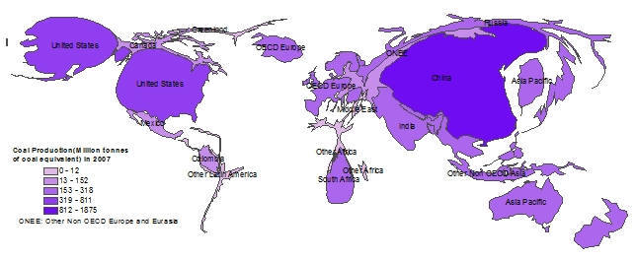
Figure 3A. Coal Producers in 2007
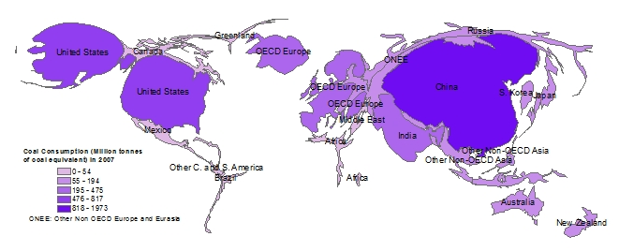
Figure 3B. Coal Consumers in 2007

Figures 3A and 3B are cartograms of coal producers and consumers respectively. The size of a region is proportional to the amount of coal produced or consumed within that period. Figure 3A illustrates that in 2007, China, the United States, Australia, India, Indonesia, Russia and South Africa as the major producers of coal. This is consistent with IEA (2009) which revealed that on an energy basis; 86% of global coal was produced by these countries. In this, China accounted for 41% of global production and the United States for another 18%.
Figure 3B shows that in 2007, China, United States, OECD Europe, India then Other Non- OECD Asia were the major consumers. Looking at figures 3A and 3B, there is little conflict in terms of the geographies of coal production and consumption. The most important problem is that 27% of world primary energy demand is supplied by coal (IEA, 2009) which remains a significant source of methane emissions. The global warming potential (GWP) of methane is 23 times (World Coal Institute, 2010 or 25 times (McKeown and Gardner, 2009) greater than that of CO₂. No matter the percentage, it has serious implication on climate change.

3.2.1 Visualising the future of coal demand and supply
The demand for coal grows higher than other fossil fuels — at an average annual rate of 1.9% — from a level of 4 548 million tonnes of coal equivalent (Mtce) in 2007 to 6 980 Mtce in 2030. The demand for coal among OECD countries caused an unprecedented rise in the price of coal globally between 2004 and 2008. The second half of 2008 witnessed a drastic fall in coal demand after many years of high demand and high prices. The demand for global coal is expected to rise with increasing demand in non-OECD countries, mainly in Asia, which accounts for 97% of incremental demand (IEA, 2009).
Figure 4A below indicates that in 2030, China and United States remain the major producers, followed by India then Other Non-OECD Asia. In this case, the production level of India is more than double between 2007 and 2030. Indonesia’s share of production is significant.
Figure 4B below illustrates that in 2030, China, United States, India, OECD Europe then Other Non-OECD Asia as the major consumers of coal. This is in line with IEA projection which states that by 2030, China’s coal demand almost double, while India’s demand more than doubles, India overtakes the United States as the world’s second-largest coal consumer behind China (IEA, 2009). In the long run, China and India remains the major consumers of coal. China and India, which in 1980 consumed one-fifth of world coal, now account for nearly half of global demand and their share is set to rise to nearly two-thirds (IEA, 2009: 89-91). This is in line with the view of Guan et al (2009) who observed that China’s energy sources have remained constant over the last decade in which coal accounts for 70% of total energy supply.
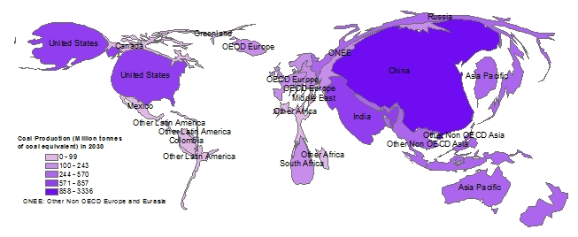
Figure 4A. Coal Producers in 2030
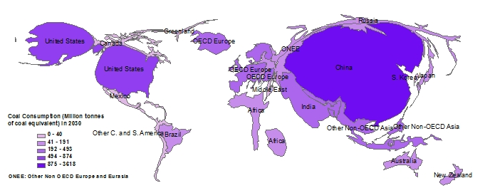
Figure 4B. Coal Consumers in 2030

Figures 3A and 3B are cartograms of coal production and consumption in 2007, whereas figures 4A and 4B display coal production and consumption in 2030. All the figures combine national and regional distributions, the sum of which shows a global trend. Visually comparing figures 3A and 4B, 3B and 4B show minimal change in global coal production and consumption. But in terms of global warming potential, the change is highly significant.

3.3 The Scenarios for gas supply and demand
3.3.1 Reference Scenario
According to IEA (2009), almost all of the projected increase in global natural gas production between 2007 and 2030 is expected from the non-OECD countries. Russia remains the world’s largest gas producer throughout the projection period, ahead of the United States. While Qatar, Iran and Russia ranked the world’s largest reserve holders of gas (IEA, 2009).
Figures 5A and 5B below display gas production in 2007 and 2030 respectively; based on the current international laws. In 2007, the major producers were Russia, United States, Canada, Iran, Norway, Algeria and Netherlands, Qatar is 13th after Saudi Arabia on the list as in figure 5A. In 2030, Russia, United States, Iran, Qatar, Canada, Algeria, Saudi Arabia, Norway, China and Australia top the list as depicted in figure 5B. It is observed that Qatar rose from 13th to one of the world’s leading gas producers. The Middle East sees the biggest increase in absolute terms, its output in 2007 continues rising and more than double in 2030. Africa, Central Asia, Latin America and Russia also see significant growth in production.
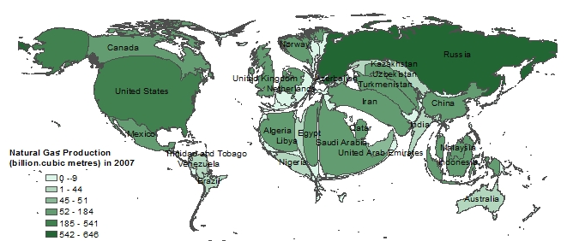
Figure 5A. Natural gas production 2007
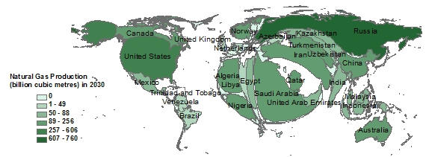
Figure 5B. Natural gas production in 2030

3.3.2 Gas supply
Trends to 2030 in gas production in the 450 Scenario depart from those of Reference Scenario. This is as a result of assumed falling international gas prices which discourage investment in exploration and development of gas infrastructure (IEA, 2009). This is visualised in figures 6A and 6B.
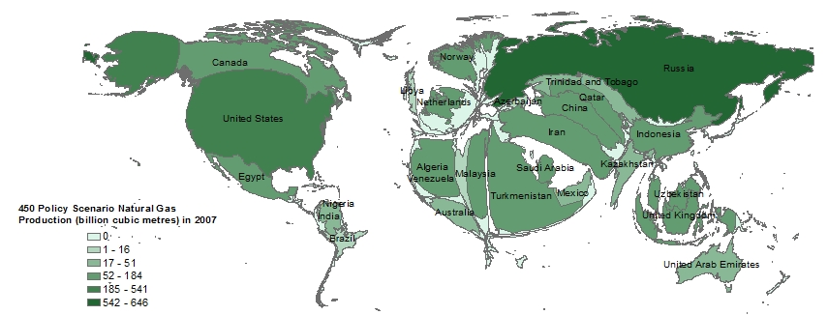
Figure 6A. Natural gas production 2007
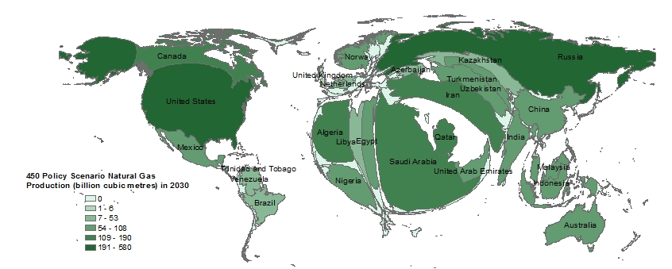
Figure 6B. Natural gas production in 2030

3.3.3 Reference Scenario for Regional Gas Demand
Although natural gas is relatively cleaner compared to other fossil fuels, the growing demand for it especially in the power sector remains a cause of concern particularly because of the cumulative global warming potential. In the IEA’s Reference Scenario, the global gas demand increases at an average rate of 1.5% per year from 2007 to 2030.
Figure 7A shows that in 2007, United States, Russia, OECD Europe are the major consumers of gas. Whereas in 2030, United States and OECD Europe maintain their position, the Middle East emerged as a major consumer. Russia’s rate of consumption decline as illustrated in figure 7B.
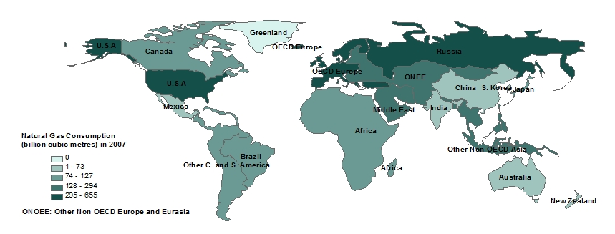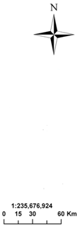
Figure 7A. Regional Natural gas consumption in 2007
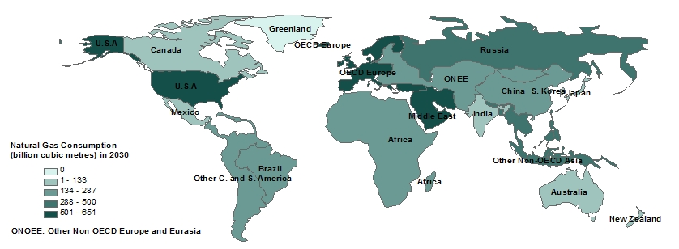
Figure 7B. Regional Natural gas consumption 2030

3.3.4 450 Policy Scenarios for Regional Gas Demand
In the 450 Scenario, global primary gas demand in 2030 is 17% lower than in the Reference Scenario. Gas demand in the OECD countries generally peaks by around the middle of the projection period in the 450 Scenario and then declines through to 2030, as generators switch investment away from coal- and gas-fired plants to plants using renewables and nuclear power. Demand continues to grow in most non-OECD regions through to 2030 (IEA, 2009: 365).
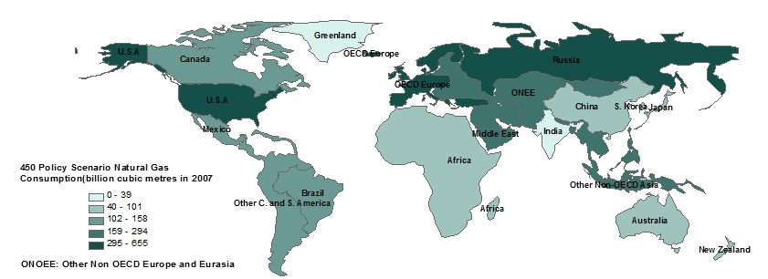
Figure 8A. Regional Natural gas consumption in 2007
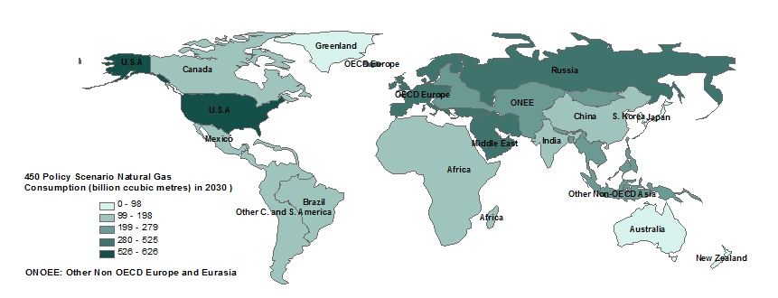
Figure 8B. Regional Natural gas consumption in 2030

It is observed that the global shift in natural gas production and consumption as well as spatial variation in gas demand and supply is more discernible using cartograms in figures 5A-6B than the choropleth maps in figures 7A-8B. This suggests that cartograms are more efficient in visualising dynamism of spatial phenomena than the choropleth maps.

4. Conclusion
Unequal spatial distribution of energy resources classifies the world into energy producers and consumers. Energy consumption pattern is dynamic because it is determined by economic and population growth. On the other hand, energy production trend is changing with advancement in exploration technology and the search for alternative cleaner sources. As the world is approaching or appears to have reached the peak of global oil production as suggested by Aleklett et al. (2010) and supported by Shell International (2008), the oil which accounts for 30% of the global primary energy supply may not meet the demand for social and economic activities leading to energy crisis. The demand and supply of coal, the fossil fuel with the highest global warming potentials, is fluctuating. In the move toward a cleaner energy resource, gas plays a significant role in the global energy system. Gas production and consumption pattern is also changing. Figures from the IEA, EIA scenarios suggest that a global shift in energy production and consumption in underway as it is determined by physical and social factors. The demand and supply of fossil fuels which dominate the global energy system is visualised as a dynamic process. The demand and supply of oil which accounts for 30% of the global energy is visualised using cartograms. Although the dynamics is clear, there is over estimation of some areas by the cartograms. The production and consumption of coal which currently is the second major source of energy is also represented using the cartograms. Evidence of change in the production and consumption pattern is seen though some areas are not clearly represented. Natural gas which plays a significant role especially in the future of global energy system is visualised using a combination of cartograms and choropleth maps. Comparing the two suggest that the cartograms provide a clearer spatial variation than the choropleths. Cartograms should be employed in energy visualisations as they prove to be intuitive and informative in visualising change and dynamic relationships.

References
Aleklett, K., Hook, M., Jakobsson, K., Lardelli, M., Snowden, S., Soderbergh, B. (2010). The peak of the oil age – analyzing the world oil production Reference Scenario in World Energy Outlook 2008. Energy Policy, 38, 1198–414.
Andresen, M.A., Wuschke, K., Kinney, J.B., Brantingham, P.J., Brantingham, P.L. (2009) Cartograms, Crime, and Location Quotients. Crime Patterns and Analysis, 2(1), 31-46. Available at: http://www.eccajournal.org/V2N1S2009/Andresen.pdf
BP. (2009). BP Statistical Review of World Energy 2009, British Petroleum, London.
Bradshaw, M.J. (2010). Global energy dilemmas: a geographical perspective. The Geographical Journal, 176(4), 275–290.
Bridge, G. (2010). Geographies of peak oil: The other carbon problem. Geoforum, 41, 523–530.
Dorling, D. (1996). Mapping Mortality Concepts and Techniques in Modern Geography Area Cartograms: Their Use and Creation. Daniel Dorling.
EIA (Energy Information Administration), (2010). International Energy Outlook 2010 EIA, Washington DC.
Gastner, M., Newman, M. (2004). Diffusion-based method for producing density-equalizing maps. Proceedings of the National Academy of Sciences, 101(20), 7499-7504.
Guan, D., Peters, G.P., Weber, C.L., Hubacek, K. (2009). Journey to world top emitter: an analysis of the driving forces of China’s recent CO₂ emissions surge. Geophysical Research Letters, 36, L04709.
Henriques, R., Bacao, F., Lobo, V. (2009). Carto-SOM: Cartogram Creation Using Self-Organizing Maps. International Journal of Geographical Information Science, 23(4), 483–511.
International Energy Agency (IEA) 2009 World Energy Outlook 2009, Paris.
IEA (2007), World Energy Outlook 2007 Paris.
IEA (2007), Key World Energy Statistics 2007 Paris.
International Panel on Climate Change (IPCC) (2007). Fourth Assessment Report, Working Group I The Physical Science Basis. Summary for Policymakers, IPCC.
McKeown, A., Gardner, G. (2009) Climate Change Reference Guide Worldwatch Institute Washington DC.
Podobnik, B. (2006) Global Energy Shifts Fostering Sustainability in a Turbulent Age Temple University Press, Philadelphia.
Shell International (2008), Shell energy scenarios to 2050. Shell International BV, Hague.
World Bank, 2010, World Development Indicators (2010), http://www.workinfo.com/Workforce/20997_devindicators.pdf
World Coal Institute http://www.worldcoal.org/coal-the-environment/climate-change/
World Resources Institute’s (WRI) Climate Analysis Indicators Tool (CAIT) http://cait.wri.org/

 

