- Methods of Research
This research uses normative legal research methods. This method conducts legal research by examining existing library materials. This paper will also be discussed based on legal theories. Thus, these assumptions will also be tested and linked based on legal theories. The data used are secondary data and analyzed based on a statutory approach. The data includes the literature, including those available online. Also, this study uses legal material, including Indonesian law related to the Electric Vehicle, books, articles/journals, seminar papers, dictionary. The data is then presented descriptively and systematically in this paper.

- Figures and Tables

Figure 1: Legal Mapping of Incentives Policies
Source: Law Number 30 Year 2007; Government Regulation Number 79 Year 2014; Government Regulation Number 70 Year 2009; President Regulation Number 55 Year 2019.

No | Fiscal Incentives (Article 19) | Non-Fiscal Incentives (Article 20)
1 | Incentives for import duty on the import of BEV; | Exclusion from restrictions on the use of certain roads;
2 | Sales tax incentives on luxury goods; | Delegation of production rights for technology related to BEV whose patent license has been held by the Central Government and/or Regional Government;
3 | Incentives for exemption or reduction of central and regional taxes; | Fostering security and/or securing the industrial sector’s operational activities to sustain or smooth logistical and/or production activities for certain industrial companies that are national vital objects.
4 | Import duty incentives on the import of machinery, goods, and materials for investment purposes;
5 | Postponement of import duties for export
6 | The Government bears import duty incentives on the importation of raw materials and/or supporting materials used in the production process;
7 | Incentives for building a charging station;
8 | Export financing incentives;
9 | Fiscal incentives for research, development, and technological innovation activities as well as industrial vocational BEV components;
10 | Parking rates at locations determined by the Regional Government;
11 | Reduction of the cost of charging electricity at charging station;
12 | Support for financing the infrastructure and development of charging station;
13 | Professional competency certifications for human resources of the BEV industry;
14 | Product certification and/or technical standards for BEV industry companies and BEV component industries.
Figure 2: List of Incentives
Source: President Regulation Number 55 Year 2019.

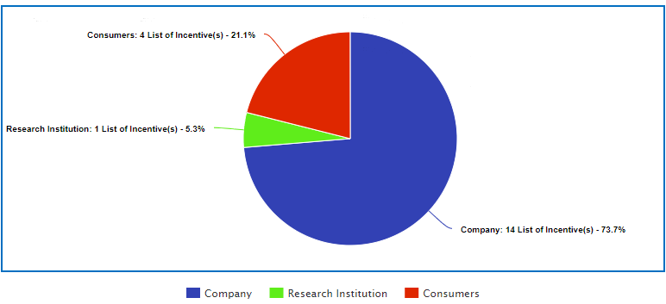

Figure 3: Incentives Holders
Source: Authors based on President Regulation Number 55 Year 2019.

