Leveraging On Sustainable Energy Transition to Change the Energy Narrative of the Dark Continent
Williams S. Ebhota
Department of Mechanical Engineering, Durban University of Technology, Durban, South Africa.
Correspondence email: Willymoon2001@yahoo.com
Abstract
This study overviews sustainable development goals (SDGs) and sustainable energy transition (SET) and then examines − sub-Sahara Africa’s (SSA) participation in SET; challenges of power inadequacy, exploitation, and deployment of zero-carbon based energy; and steps to fast track renewable energy (RE) development and utilisation. The study identifies factors responsible for power inadequacy in the region to include poor power equipment manufacturing infrastructure, pillaging of power projects funds, use of obsolete power facilities, lack of maintenance of power facilities and stations, and abandonment of power facilities due to breakdown. The world’s quest to shift from the consumption of fossil fuels to RE has worsened the possibility of SSA overcoming these challenges. The study recognises the management of this shift and modern power attributes, such as decarburisation, digitization, and decentralisation, as to mitigate energy poverty and security, and climate change in the region, as the focus of sustainable energy transition (SET). The study pointed out that the critical steps that are required for socioeconomic growth and to change the negative energy narrative of SSA include − RE domestic capacity building; RE policy reforms to support R&D for rapid development; reversed engineering approach; and other steps necessary to improve RE development.
Keywords: Renewable energy; sustainable energy transition; SDGs; Dark Continent; CO2 emission; GHG

Introduction
Africa was called the “Dark Continent” in the 19th century by the European explorers because it was vast and strange (Amin, Steiner, & Yumkella, 2012 ); coincidentally, the continent is comparatively dark in the 21st century due to inadequate and erratic power supply. The situation is worse in sub-Sahara Africa (SSA). Generally, the basic infrastructure in Africa is poor; citizens provide virtually everything (road, power, medical, school) for themselves, a situation that has tagged Africa as “provide-your-own-infrastructure” continent. Energy availability is strongly related to socioeconomic development; electrical energy is the live wire, and a critical driver of economy and modern society. “No electricity, no industrialisation and development, consequently, an invitation to abject poverty”. In the quest to meet the required energy for economic development, the environment, and human health are often traded off. In SSA, access to modern energy grossly inadequate, despite the health and environment compromise. About 50% of the population in 41 countries of SSA have no access to electricity, and only 59% is expected to access power by 2030 (IEA, 2017). The most exploited energy sources in the region are fossil and biomass; more than 90% of the households in about 25 countries of SSA rely on waste, wood, and charcoal for cooking. The resultant effects of these practices are greenhouse gases (GHG) emissions leading to climate change, morbidity and mortality increase. An average annual rate of 4% increase in electricity is expected by 2040.
The region’s residential sector average annual electricity consumption estimate is 488 kilowatt hours (kWh) per capita, which is only about 5% of the United States consumption (Morrissey, 2017). Apparently, 2030 has been declared as the year for universal access to affordable, reliable and modern energy services. The need for adequate and quality power supply to boost the socio-economic profile of the continent has long been recognised. Subsequently, a lot has been said, planned and executed at both local and international platforms, on how to facilitate the lighting up of ‘the Dark Continent’; and propel the region into the global economy, but without significant achievement. All the efforts and interventions geared toward electrification since the 1970s have not yielded the expected results. This has been attributed to several factors, which include: dictators pillaging power projects funds, inadequate manufacturing infrastructure to support the production of power equipment in the region, lack of maintenance of existing power stations; and abandonment due to breakdown, use of obsolete power facilities, and so on. Overcoming the power challenges in SSA is further compounded by the global quest for fossil fuel replacement with affordable, adequate, clean, and sustainable energy resources (WEC, 2016). This situation coupled with the global technologies landscape have made the power interventions ineffective, resulting to six categories of disruptors in the sector - African economic growth; shifting the energy mix; changing the role of customers; renewable technology; smart grids, smarter utilities; and changing market structures and dynamics. The pathway towards the transformation of the global energy sector, from fossil-based to zero-carbon energy is comparatively slow in the global south, especially in SSA. The region is already counting her losses due to climate change consequences triggered by human activities, such as energy generation and consumption with CO₂ emission as a consequence (Aljazeera, 2019; FloodList, 2019a, 2019b).
This study aims to identify entwined factors that impede the development of RE in SSA and the possible ways of fast tracking RE development in SSA. Therefore, this study examines the global perspective on sustainable energy transition (SET), SSA participation; and identify the factors responsible for power inadequacy and the slow pace of SET in SSA; steps to accelerate the region’s participation in SET to change the negative energy narrative of the region; and contemporary RE research areas for SSA targeted at catch up with SET and energy deficit in the region.
The remaining part of the article is structured in sections as follows: Sect. – “Methodology” presents the research methodology; Sect. – “Overview: sustainable development goals (SDGs)” reviews SET’s necessitation and discusses how energy interconnects other goals and RE relevance in meeting SDGs; Sect. “Sustainable energy transition (SET)” synopses SET aim and objectives and its contemporary drivers; Sect. “The participation of sub-Sahara Africa (SSA) in SET” provides analysis and evaluation of SSA energy transition level and activities; Sect. “Sub-Saharan Africa electrification limiting factors” outlines challenges of energy supply in SSA; Sects. “Changing the energy narrative and bracing up for 100% RE Region” and “Conclusion” deal with steps to be taken to change the negative energy narrative of SSA, and overview of the article, respectively.

Methodology
This study is based on contemporary issues, technological advancement, opinions, and review of articles on RE policy; and methods to promote SET sensitisation, investment, and utilisation of RE in SSA. A wide review was carried out, considering literature published mostly in the last five years, relevant to this research. This study was performed in the following approach: secondary data gathering through such platforms as ScienceDirect, Scopus, verified official websites of published feasibilities, reports, and investigations by global organisations on RE, energy policies, SET, power issues in SSA, SDGs, energy investments, and climate change— Intergovernmental Panel on Climate Change (IPCC), the World Bank, and the United Nations (UN). Other sources of data include national energy departments and international energy organisations, such as national governments' report, International Energy Agency (IEA), World Energy Council, (WEC), and International Renewable Energy Agency (IRENE).

Overview: sustainable development goals (SDGs)
Over the years, human existence and activities targeted at satisfying human needs have adversely affected the planet, leading to serious global environmental and socio-economic challenges. These challenges include poverty, hunger, ill-health, climate change, water, sanitation, energy, urbanization, and social justice. However, different countries and regions are affected by these challenges at different degrees. To address or stop the escalation of these aforementioned global challenges, the United Nations (UN) came up with targets, generally refer to as sustainable development goals (SDGs) (UN, 2015b). There are 17 set goals of SDGs, which cover a range of socio-economic development challenges, as shown in Figure 1 and Table 1. The SDGs goals are aimed at ending poverty, protect the planet and ensuring that all people enjoy peace and prosperity by 2030. The seventh goal (renewable energy, RE) in the SDGs, is interconnected to several other goals, such as – no poverty, zero hunger, good health and well-being, quality education, clean water and sanitation, affordable and clean energy, decent work and economic growth, industry, innovation and infrastructure, climate action, responsible consumption and production. It would be difficult, therefore, for developing countries that are struggling with power supply to realise many of the objectives of the SDGs. The chase for adequate energy to satisfy the increasing demand is central to socioeconomic, climate change, environmental, and developmental challenges facing the world today. Subsequently, the modern energy systems are expected to meet the following sustainability criteria in accordance with the UN recommendations (Nentura; Wyman, 2015) - produce low to zero CO₂ emission; balance capital-intensive investments for network advancements; impact local energy self-reliance, and security; and stimulate social investment and inclusiveness. According to World Energy Council (WEC), energy sustainability is a system of energy supply with three components - energy security, energy equity, and environmental sustainability that are interconnected. This tripodal relation is termed “energy trilemma” (Nentura; Tomei & Gent, 2015; Wyman, 2015).
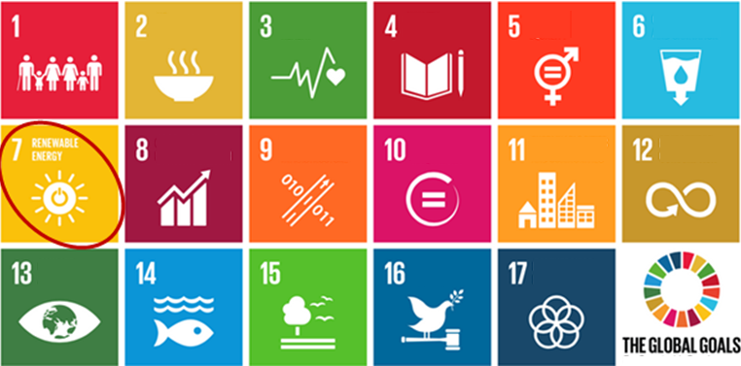
Figure 1: The 17 set goals of the United Nations SDGs (UN, 2015b)
Table 1: The 17 set goals of SDGs.
1. No poverty | 2. No hunger | 3. Good health
4. Quality education | 5. Gender equality | 6. Clean water and sanitation
7. Affordable and clean energy | 8. Decent work and economic growth | 9. Innovation and infrastructure
10. Reduced Inequality | 11. Sustainable cites and communities | 12. Responsible consumption
13. Climate action | 14. Life below water | 15. Life on land
16. Peace justice | 17. Partnerships for the goals

Sustainable energy transition (SET)
The generation of energy needed for the growing population, industrialisation, and urbanisation has been identified as one of the vital human activities manifesting serious challenges. The situation is worse in developing countries presently experiencing inadequate, and poor power supply. Fossil fuels (oil, natural gas, and coal) are undoubted, reliable economic boosters, however, they come with negative environmental and health consequences, such as CO₂ emissions and natural resources depletion (Williams Saturday Ebhota, 2019). This has resulted in a global outcry for a sustainable energy system that is secure, adequate, affordable, and environmental friendly (Williams S Ebhota & Jen, 2018; Gent & Tomei, 2017; Harvey, 2014; Heffron, McCauley, & Sovacool, 2015; Rahman, Sakhawat, Amin, & Ahmed, 2012). In response, the United Nations (UN) has resolved to reduce the consumption of fossil fuels through the deployment of more RE (UN, 2015a; Wangjiraniran & Eua-arporn, 2012). Since energy is what powers economic growth, the development or use of alternative energy sources to fossil fuels is now a necessity. A shift from fossil fuel economy paradigm to a sustainable alternative energy concept for the supply of adequate, clean and affordable power supply has long started and the transition success depends on several dynamics. The control of these complex global energy dynamics is challenging and significant to energy poverty, energy security, and climate change mitigation. Sustainable energy transition (SET), therefore, involves the management of this shift and modern power sector dynamics, such as digitization, de-carbonization, and decentralization. This power sector transformation is coming at the time SSA is seriously in need of energy, and hence, compounds the meeting of SDGs and the energy deficit of the region. The idea behind SET will simply be a mirage if there are no alternatives to the perilous fossil fuels. The known natural sources of clean, reliable and renewable energy with low or zero GHG emissions are sun (solar), small hydropower, geothermal, wave and wind. Developed countries have substantially developed RE systems while many developing countries including the ones in SSA are still foot-dragging. The level of investment in RE could be a measure of commitment towards the realisation of a sustainable energy system. Investment in RE by both developed and developing countries is shown in Figure 2. The chart shows that the investment in RE in the global south, excluding China and India, is comparatively low.
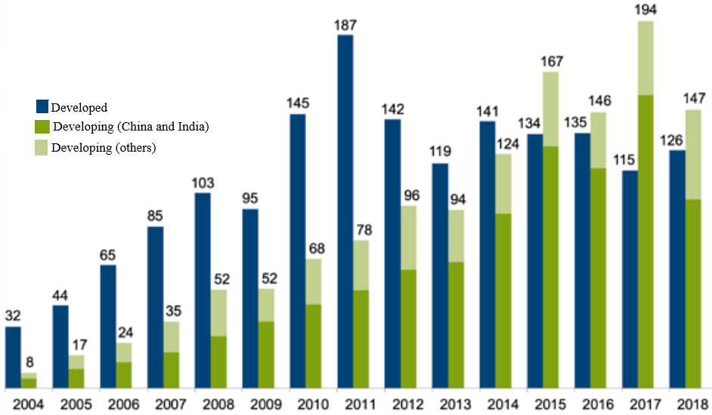
Figure 2: Investment in RE capacity - developed vs developing countries, 2004-2018, USD (billion) [22].

The participation of sub-Sahara Africa in SET
The rate of power infrastructural growth in SSA falls far below the rate of power increase due to rapidly growing population, industrialisation and urbanisation. Lack of adequate access to energy is a denial of social justice to the poor people in the region. They are grossly deprived of customs and modern society practices participation. Globally, SSA accommodates the highest population without access to electricity and the number of people living in extreme poverty (Katayama & Wadhwa, 2019). For a quick response, SSA countries should take advantage of the attractive merit of RE system – wind farm takes between 9 to 12 months; solar park takes between 3 to 6 months to complete compared to fossil fuel plant that takes years. The region must be at the forefront to exploit the SET advantage and its programmes to provide adequate, clean, reliable, and affordable energy to her poor population. Sadly, that is not the case, rather, the region's participation in SET is comparatively low and passive. The RE investments from 2009-2019 (USD, billion) of selected regions and countries including South Africa is shown in Fig 3. It is obvious that South Africa’s investment in RE is comparatively low despite having the highest share of the total RE installed capacity and investment in SSA. This means that the region cannot make a substantial change in its poor energy status.
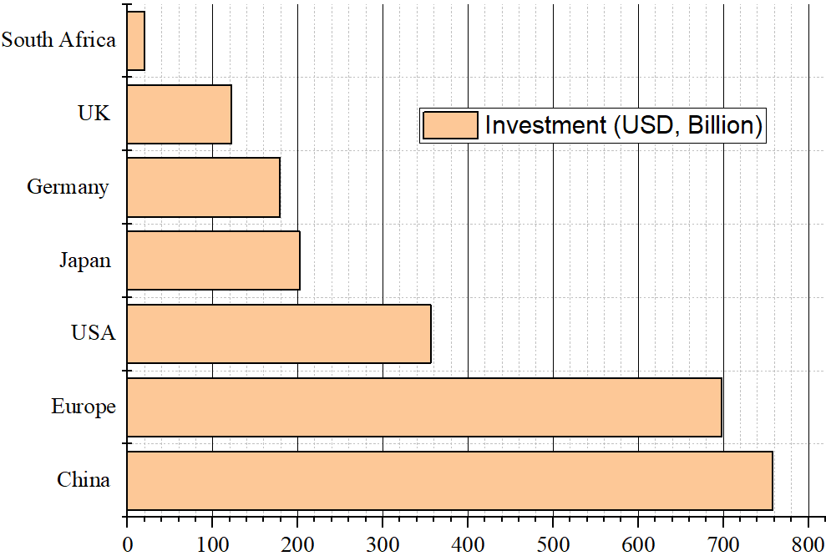
Figure 3: Renewable energy investments from 2009-2019
(USD, billion) of selected regions and countries (UNEP-BloombergNEF, 2019).The global RE investment and deployment have been increasing exponentially over the years. This study identifies some factors, as presented in Table 2, responsible for the new RE financial and deployment characteristics.
Table 2: New RE financial and deployment dynamics
Renewable energy deployment dynamics
Research and Development (R&D) | Capacity investment in RE | Cost reduction
Policy support | Sustainable goals

Sub-Saharan Africa electrification limiting factors
Several power projects have been executed and many others are still ongoing. Many crucial power installations were carried out across SSA in 2013, as presented in Table 3. The efforts and interventions geared toward electrification since the 1970s have not yielded the expected results. This has been attributed to several factors (Anarfo, Abor, & osei, 2020; Garrone, Piscitello, & D'Amelio, 2019; Imam, Jamasb, & Llorca, 2019; Myovella, Karacuka, & Haucap, 2019; Sievert & Steinbuks, 2020), which include − poor power equipment manufacturing infrastructure; pillaging power projects funds; use of obsolete power facilities; lack of maintenance of power stations; and abandonment of power facilities due to breakdown. The world’s chase to substitute or reduce the consumption of fossil fuels with affordable, clean, and sustainable energy resources has worsened the possibility of overcoming these issues.
Table 3: Sub-Saharan Africa installed power capacity and Gross Domestic Product, 2013 (Williams Saturday Ebhota, 2019)
Country | Capacity (MW) | GDP (PPP) 2013 (current int’l $, billions)
Nigeria | 7,044 | 972.65
Sudan | 3,038 | 153.09
Ghana | 2,812 | 103.65
Congo, Dem. Rep. | 2,444 | 50.47
Mozambique | 2,382 | 28.40
Ethiopia | 2,094 | 129.86
Zambia | 1,985 | 57.07
Zimbabwe | 1,970 | 25.92
Kenya | 1,766 | 124.02
Tanzania | 1,659 | 117.66
Côte d’Ivoire | 1,521 | 65.55
Angola | 1,509 | 166.11
Cameroon | 1,238 | 69.98

Changing the energy narrative and bracing up for 100% RE in SSA
There is a strong correlation between energy usage and economic growth; provision of adequate and affordable energy is required to stimulate economic growth, and this comes with emission challenges. Presently, climate change concern is more critical in SSA, a region with the world's fastest-growing populations, inequality, and high level of poverty. The climate change events, such as high temperature, flooding, cyclone, and drought are already being experienced in the region. Africa accommodates 86 of the world's 100 fastest growing cities and 79 of these cities are classified as being at "extreme risk" of climate change (Menzies, 2019). Hence, an urgent need to access and use energy with lower CO₂ emission, to mitigate climate change around the region. Changing the narrative of the coincidental “Dark Continent” to a “Light continent” will require a multifaceted approach. China’s RE success model can be adopted by SSA to develop the huge available RE resources in the region. This involves several measures, which are somehow interconnected and therefore, their consideration and eventual execution must be simultaneous.
The actionable critical steps to accelerate the supply of adequate, affordable and clean energy capable of changing the negative energy narrative of SSA are discussed in subsections VII.1 to VII.V. These critical steps include - RE domestic capacity building; RE policy reforms for rapid development and deployment; policy to support RE R&D; reversed engineering approach; and other steps necessary to improve RE development.

Renewable energy domestic capacity building
How does one correlate this statement: “SSA Africa is endowed with SHP potential and other RE resources (IEA, 2014; Oxlam, 2017), has the highest percentage of untapped hydropower potential (Ouedraogo, 2017) and yet, has the highest population without adequate access to power in the world”? The estimated technical generation potential of RE in the region is put at 11,000 GW (Oxlam, 2017). This can simply be put as living in energy poverty amid abundant natural energy resources. The region's inability to add adequate value or transform natural resources into desirable products is responsible for this. Domestic participation in the design and manufacturing of RE devices and systems in SSA will promote access to clean, and affordable electricity required to stimulate the region’s economy. The power supply in the region will always be threatened by overdependence on foreign technology, which comes with outcome of high cost of power project execution, installation, operation, maintenance, and repair challenges.
As it stands today, the region lacks sufficient RE technical skilled personnel and manufacturing infrastructure and this creates challenges for domestic RE components and system production. Domestic manufacturing of RE components and systems can be achieved through regional joint RE technology capacity building in the following areas: fluid mechanics; manufacturing processes; foundry technology; mechatronics; and material development engineering. Domestic capacity development of RE components and systems manufacturing will substantially reduce the cost of RE projects, operations, and maintenance (O&M), and downtime in the region. Therefore, domestic capacity building in design, manufacturing, and management of production infrastructure of RE components, devices and systems is a key to sustainable energy delivery. China is making tremendous progress in RE deployment because both RE skilled personnel and manufacturing facilities are domestically adequate in China.

Effective policy reforms for rapid RE development and deployment
The rural and remote areas of SSA are worse affected by both inadequate energy access and poverty. Addressing rural energy issues in the region will have a multiplier effect that could cumulate into an improved economy and standard of living in the region. Effective policy frameworks ranging from cross-cutting to sector-specific policies are required to create enabling conditions for the development of mini-grid markets. Such conditions include subsiding for RE usage, easy of private investment in the sector and tariff setting for private investment payback time. A policy that will incentivize and/or subsidise RE investment of a defined capacity and usage should be put in place to drive RE development and deployment. The policy should include - long-term planning for rural RE development and deployment, strengthening and sustaining of rural RE supply, since rural areas of the region are worse affected by power inadequacy. Amongst other things that the policy should address are: subsidising commercial bank interest rate on loans for RE projects, covering small-scale manufacturing of wind turbine; small hydropower; photovoltaic components; solar water heater; bagasse power plant; and other small/mini scale RE projects.

Policy to support RE R&D
The global RE competition is on stage, and it will be won on the RE R&D platform. This is already being played out amongst the leading RE technology in Asia, Europe, and America. Developing south's (SSA) success and competitiveness in RE development and deployment largely depend on − how much resources that are invested in RE R&D; RE R&D priorities; the quality and organisation of R&D personnel, facilities and activities in the region; and how the R&D addresses the region's peculiar RE issues. Therefore, a robust policy that encourages and aids R&D that are directed towards the development of affordable, adequate, and clean RE should be a necessity in SSA.

The need for domestic RE technology in SSA
Overcoming the huge power deficit and continuous deterioration of power infrastructure in SSA requires domestic capacity to design, fabricate, and maintain power technologies and facilities (Williams S. Ebhota & Inambao, 2016; Williams S. Ebhota & Inambao, 2019; Moner-Girona et al., 2018). New and improved RE devices, systems, and production technologies are products of R&D. Hence, a well-coordinated, adequate, and sustained investment in alternative energy R&D and transformation is key to SET success. New RE products and processes based on the region’s peculiarities need to be developed for sustainable transition to occur. The outcomes of proposed R&D are expected present RE options that are affordable, environmental friendly, and sustainable. Undoubtedly, R&D and manufacturing are critical drivers of SET; the advances and breakthrough in R&D need to be manufactured into end users demand products. Considering the impacts of inadequate energy supply, the use of fossil fuel and climate change in SSA, the region should be in the forefront of RE R&D.
Renewable energy R&D should cover every aspect of RE system, from generation to distribution technologies. This includes energy generation and storage materials, demand management, and conservation (W. S. Ebhota & Tabakov, 2020). Impact of pricing, technical improvements, physical and legal controls, and education and promotion on energy demand should not be left out. The region should take advantage of RE emerging technologies and invest in R&D in the areas presented in Table 3.
Table 3: Renewable energy emerging technologies and invest R&D areas
Photovoltaic (PV) technologies
Concentrated PV (CPV) cells | Perovskite PV cells | Crystalline Silicon
Nanoﬁbre PV cells | Dye PV cells | Cadmium Telluride (CdTe)
Inverter | Silicon germanium (SiGe) PV cells | Copper Indium Gallium Diselenide (CIGS)
Hybrid Organic-Inorganic Halide | Multi‐junction /Tandem /Cascaded PV cells
Geothermal
Evaluate sustainability of geothermal production | Cost of construction | Policy to break geothermal barriers
Techno-economic assessment | Heat exchanger materials
Hydroelectricity
Hydraulic performance testing and improved flow measurement | Small hydropower | Storage pump, turbine configuration,
Certification and verification of hydropower as green energy | Optimisation of control system | Improving the efficiency of small hydro turbine
Cost reduction strategies for maintenance of facilities | Predictive Maintenance/Repair and Condition Monitoring | New technology to enhance downstream water quality
Simulation and optimization models for machine and operational improvements, etc. | Improving environmental flow requirements at peaking projects | Water quality management and mitigation
Wind turbine
Wind turbine mechanical structure and material | Developing standards for wind turbine design | Operation and maintenance strategies
Operation and maintenance strategies | Wind turbine flow device | Wind turbine control system.
Wind turbine monitoring, control, and reliability. | Reducing component weight and manufacturing costs | Grid integration and optimizing performance, etc
Energy storage technology
Battery Material with potential of higher energy density | Lithium-ion battery | Lithium-Sulphur batteries
Ultra-capacitors | Flywheels | Battery modelling and simulation
Battery charging system | Improving the life of low-cost, compact, lightweight batteries, etc.
Energy smart grid technology
Energy smart meters and advanced metering infrastructure | Smart grid costs | Smart application integration platform
Forecast of energy consumption in the different sectors | Smart grid simulation
Electric vehicles
Development of potential DC fast chargers | Electric vehicle grid impact assessment | Electric vehicle technology technical and economic feasibility in SSA
Solar-powered electric vehicles | Fuel optimisation hybrid vehicle | Battery charging infrastructure for commercial and public application, etc.
Electrical air conditioning and heating systems for electric vehicles | Alternative source systems of in-vehicle electricity production | Battery/energy management and charging systems
Braking systems for electrical propulsion and traction systems

Reversed engineering approach
The power supply in the region will always be threatened by overdependence on foreign technology, which comes with consequences of high cost of power equipment, project execution, installation, operation, maintenance, and repair challenges. The domestic development of RE capacities can be expedited through reversed engineering and technology adaptive approach; the use of locally sourced materials and production facilities for RE components and systems manufacturing (W. S. Ebhota, Karun, & Inambao, 2016 ; Williams S. Ebhota, Karun, & Inambao, 2017).

Other steps necessary to improve RE development
Additional steps necessary to improve RE development in SSA are – the execution of RE projects through government-private partnership scheme; promotion of RE development and deployment through regional joint programme; RE potential sites assessment for information collection and feasibility studies; formulation of policy that will provide incentives and encourage existing fossil fuel-based electricity providers to embark on RE R&D; and the formulation of policy framework that limits the bureaucratic process in RE investments.

Conclusion
Sub-Sahara Africa countries are entangled with chronic power supply issues and poor basic infrastructure, compelling individuals and organisations to provide-their-own-infrastructure. Africa that was described as a “Dark Continent” by the European explorers in the 19th century because of its vastness, has no adequate power supply to light up the streets in 21st century. Some of the factors that account for this are − poor power equipment manufacturing infrastructure in the region; pillaging power projects funds; use of obsolete power facilities; lack of maintenance of power stations; and abandonment of power facilities due to breakdown. The world’s quest to replace fossil fuels with affordable, clean, adequate, and sustainable energy resources has heightened the possibility of overcoming these challenges. The pace of shifting from fossil fuel economy paradigm to sustainable alternative energy system depends on the effective management of the complex global energy dynamics. This is key to the mitigation of energy poverty and security, and climate change in the region, which is the focus of SET. Sustainable energy transition deals with the management of this shift and the modern power attributes, such as digitization, de-carbonization, and decentralization. Considering RE investment and technology advancement levels in Europe, America, and Asia, comparatively, the participation of SSA in SET is low and passive. Changing the negative of SSA energy narrative requires the following critical steps − RE domestic capacity building; RE policy reforms for rapid development and deployment; policy to support RE R&D; reversed engineering approach; and periodic assessment and feasibility studies of RE potential sites for data collection and planning.

References

